**LECTURE NOTES**

**ON**

PRINCIPLES OF PROGRAMMING LANGUAGE

**III B-Tech I Semester**



**INFORMATION TECHNOLOGY**

**CMR TECHNICAL CAMPUS**

**KANDLAKOYA (V), MEDCHAL**



**CMR TECHNICALCAMPUS**

Kandlakoya (V), Medchal Road, Hyderabad-501401.

LECTURE NOTES

Principles of Programming Language

UNIT-I

Preliminaries

Topics

1. Reasons for Studying Concepts of Programming Languages

2. Programming Domains

3. Language Evaluation Criteria

4. Influences on Language Design

5. Language Categories

6. Language Design Trade-Offs

7. Implementation Methods

8. Programming Environments

`

Background

→ ―Frankly, we didn‘t have the vaguest idea how the thing [FORTRAN language and compiler] would work out in detail. …We struck out simply to optimize the object program, the running time, because most people at that time believed you couldn‘t do that kind of thing. They believed that machined-coded programs would be so inefficient that it would be impractical for many applications.‖

-John Backus

→ Unexpected successes are common - the browser is another example of an unexpected success

1.1 Reasons for Studying Concepts of Programming Languages

➢ Increased ability to express ideas

➢ Improved background for choosing appropriate languages ➢ Increased ability to learn new languages

➢ Better understanding of significance of implementation ➢ Overall advancement of computing

1.2 Programming Domains

• Scientific applications

– Large number of floating point computations

– Fortran

• Business applications

– Produce reports, use decimal numbers and characters

– COBOL

• Artificial intelligence

– Symbols rather than numbers manipulated

– LISP

• Systems programming

– Need efficiency because of continuous use

Principles of Programming Language

- C

• Web Software

– Eclectic collection of languages: markup (e.g., XHTML), scripting (e.g.,

PHP), general-purpose (e.g., Java)

1.3 Language Evaluation Criteria

• Readability: the ease with which programs can be read and understood

• Writability: the ease with which a language can be used to create programs

• Reliability: conformance to specifications (i.e., performs to its specifications)

• Cost: the ultimate total cost

Evaluation Criteria: Readability

• Overall simplicity

– A manageable set of features and constructs

– Few feature multiplicity (means of doing the same operation)

– Minimal operator overloading

• Orthogonality

– A relatively small set of primitive constructs can be combined in a

relatively small number of ways

- Every possible combination is legal

• Control statements

– The presence of well-known control structures (e.g., while statement)

• Data types and structures

– The presence of adequate facilities for defining data structures

• Syntax considerations

– Identifier forms: flexible composition

– Special words and methods of forming compound statements

– Form and meaning: self-descriptive constructs, meaningful keywords

Evaluation Criteria: Writability

• Simplicity and orthogonality

– Few constructs, a small number of primitives, a small set of rules for

combining them

• Support for abstraction

– The ability to define and use complex structures or operations in ways

that allow details to be ignored

• Expressivity

– A set of relatively convenient ways of specifying operations

– Example: the inclusion of for statement in many modern languages

Evaluation Criteria: Reliability

• Type checking

– Testing for type errors

• Exception handling

– Intercept run-time errors and take corrective measures

• Aliasing

– Presence of two or more distinct referencing methods for the same

memory location

• Readability and writability

– A language that does not support ―natural‖ ways of expressing an

algorithm will necessarily use ―unnatural‖ approaches, and hence reduced reliability

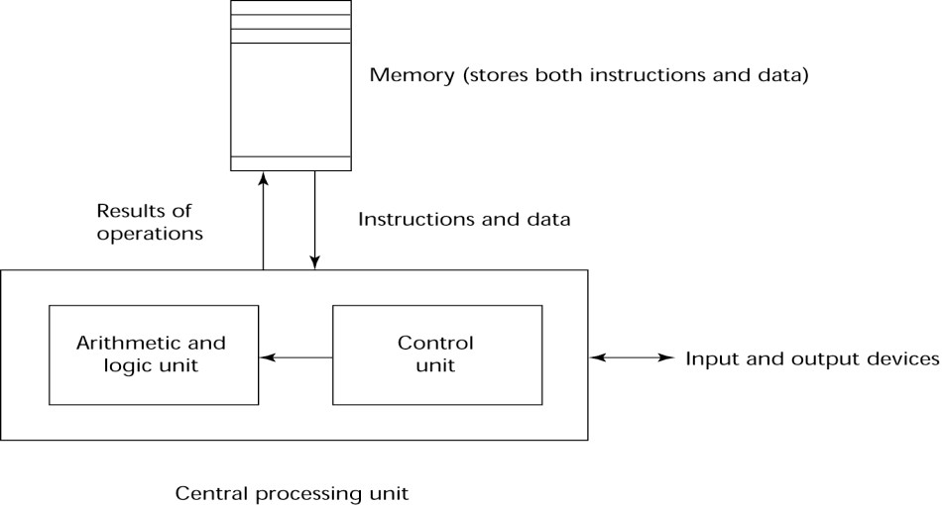

Principles of Programming Language

Evaluation Criteria: Cost

• Training programmers to use language

• Writing programs (closeness to particular applications)

• Compiling programs

• Executing programs

• Language implementation system: availability of free compilers

• Reliability: poor reliability leads to high costs

• Maintaining programs

Evaluation Criteria: Others

• Portability

– The ease with which programs can be moved from one implementation to

another

• Generality

– The applicability to a wide range of applications

• Well-definedness

– The completeness and precision of the language‘s official definition

1.4 Influences on Language Design

• Computer Architecture

– Languages are developed around the prevalent computer architecture,

known as the von Neumann architecture

• Programming Methodologies

– New software development methodologies (e.g., object-oriented software

development) led to new programming paradigms and by extension, new programming languages

Computer Architecture Influence

• Well-known computer architecture: Von Neumann

• Imperative languages, most dominant, because of von Neumann computers

– Data and programs stored in memory

– Memory is separate from CPU

– Instructions and data are piped from memory to CPU

– Basis for imperative languages

• Variables model memory cells

• Assignment statements model piping

• Iteration is efficient

The von Neumann Architecture

Principles of Programming Language

Programming Methodologies Influences

• 1950s and early 1960s: Simple applications; worry about machine efficiency

• Late 1960s: People efficiency became important; readability, better control

structures

- structured programming

– top-down design and step-wise refinement

• Late 1970s: Process-oriented to data-oriented

– data abstraction

• Middle 1980s: Object-oriented programming

– Data abstraction + inheritance + polymorphism

1.5 Language Categories

• Imperative

– Central features are variables, assignment statements, and iteration

– Examples: C, Pascal

• Functional

– Main means of making computations is by applying functions to given

parameters

- Examples: LISP, Scheme

• Logic

– Rule-based (rules are specified in no particular order)

– Example: Prolog

• Object-oriented

– Data abstraction, inheritance, late binding

– Examples: Java, C++

• Markup

– New; not a programming per se, but used to specify the layout of

information in Web documents

- Examples: XHTML, XML

1.6 Language Design Trade-Offs

• Reliability vs. cost of execution

– Conflicting criteria

– Example: Java demands all references to array elements be checked for

proper indexing but that leads to increased execution costs

• Readability vs. writability

– Another conflicting criteria

– Example: APL provides many powerful operators (and a large number of

new symbols), allowing complex computations to be written in a compact program but at the cost of poor readability

• Writability (flexibility) vs. reliability

– Another conflicting criteria

– Example: C++ pointers are powerful and very flexible but not reliably

used

1.7 Implementation Methods

• Compilation

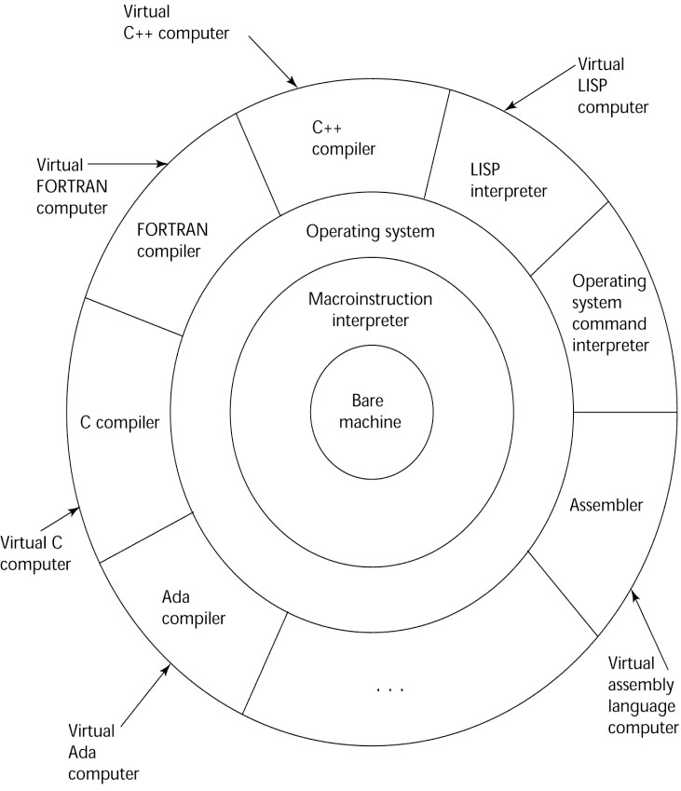

Principles of Programming Language

- Programs are translated into machine language

• Pure Interpretation

– Programs are interpreted by another program known as an interpreter

• Hybrid Implementation Systems

– A compromise between compilers and pure interpreters

Layered View of Computer

The operating system and language implementation are layered over Machine interface of a computer

Compilation

• Translate high-level program (source language) into machine code (machine language)

• Slow translation, fast execution

• Compilation process has several phases:

– lexical analysis: converts characters in the source program into lexical

units

- syntax analysis: transforms lexical units into parse trees which represent

the syntactic structure of program

- Semantics analysis: generate intermediate code

– code generation: machine code is generated

The Compilation Process

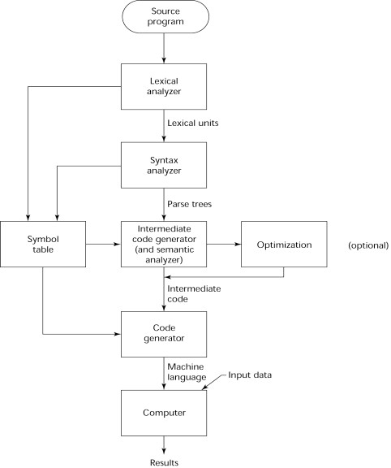

Principles of Programming Language

Additional Compilation Terminologies

• Load module (executable image): the user and system code together

• Linking and loading: the process of collecting system program and linking them

to user program

Execution of Machine Code

• Fetch-execute-cycle (on a von Neumann architecture)

initialize the program counter repeat forever

fetch the instruction pointed by the counter increment the counter

decode the instruction   
 execute the instruction end repeat

Von Neumann Bottleneck

• Connection speed between a computer‘s memory and its processor determines the speed of a computer

• Program instructions often can be executed a lot faster than the above connection speed; the connection speed thus results in a bottleneck

• Known as von Neumann bottleneck; it is the primary limiting factor in the speed of computers

Pure Interpretation

• No translation

• Easier implementation of programs (run-time errors can easily and immediately

displayed)

• Slower execution (10 to 100 times slower than compiled programs)

• Often requires more space

• Becoming rare on high-level languages

Significant comeback with some Web scripting languages (e.g., JavaScript)

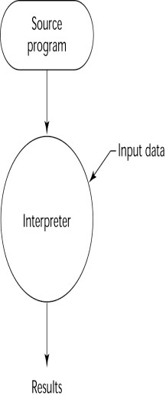

Principles of Programming Language

Hybrid Implementation Systems

• A compromise between compilers and pure interpreters

• A high-level language program is translated to an intermediate language that

allows easy interpretation

• Faster than pure interpretation

• Examples

– Perl programs are partially compiled to detect errors before interpretation

– Initial implementations of Java were hybrid; the intermediate form, byte

code, provides portability to any machine that has a byte code interpreter and a run-  
time system (together, these are called Java Virtual Machine)

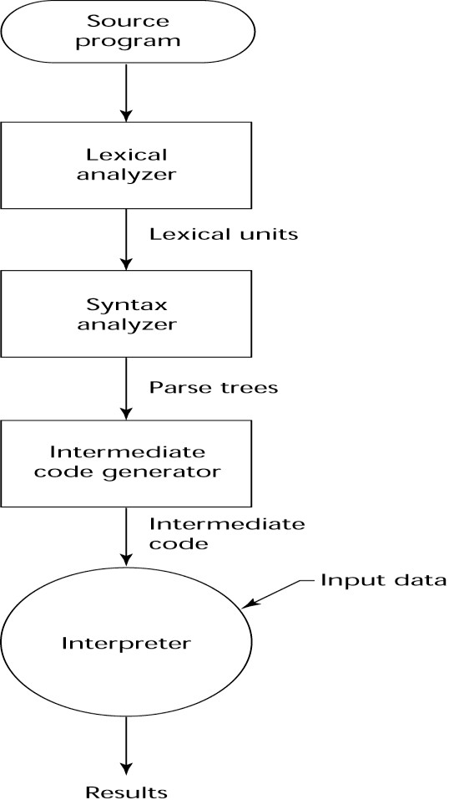

Principles of Programming Language

Just-in-Time Implementation Systems

• Initially translate programs to an intermediate language

• Then compile intermediate language into machine code

• Machine code version is kept for subsequent calls

• JIT systems are widely used for Java programs

• .NET languages are implemented with a JIT system

Preprocessors

• Preprocessor macros (instructions) are commonly used to specify that code from another file is to be included

• A preprocessor processes a program immediately before the program is compiled to expand embedded preprocessor macros

• A well-known example: C preprocessor

– expands #include, #define, and similar macros



Principles of Programming Language

UNIT-2

Syntax and Semantics

Describing Syntax and Semantics

Topics

Introduction

The General Problem of Describing Syntax Formal Methods of Describing Syntax   
Attribute Grammars

Describing the Meanings of Programs: Dynamic Semantics

2.1 Introduction

Syntax: the form or structure of the expressions, statements, and program   
units

Semantics: the meaning of the expressions, statements, and program units Syntax and semantics provide a language‘s definition

o Users of a language definition

▪ Other language designers ▪ Implementers

▪ Programmers (the users of the language)

2.2 The General Problem of Describing Syntax: Terminology   
 A sentence is a string of characters over some alphabet   
 A language is a set of sentences

A lexeme is the lowest level syntactic unit of a language (e.g., *, sum, begin) A token is a category of lexemes (e.g., identifier)

Formal Definition of Languages

Recognizers

o A recognition device reads input strings of the language and decides   
 whether the input strings belong to the language

o Example: syntax analysis part of a compiler

o Detailed discussion in Chapter 4 Generators

o A device that generates sentences of a language

o One can determine if the syntax of a particular sentence is correct by   
 comparing it to the structure of the generator

2.3 Formal Methods of Describing Syntax

Backus-Naur Form and Context-Free Grammars

o Most widely known method for describing programming language syntax Extended BNF

o Improves readability and writability of BNF Grammars and Recognizers

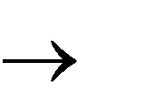

Principles of Programming Language

BNF and Context-Free Grammars

o Context-Free Grammars

o Developed by Noam Chomsky in the mid-1950s

o Language generators, meant to describe the syntax of natural languages

o Define a class of languages called context-free languages

Backus-Naur Form (BNF)

Backus-Naur Form (1959)

o Invented by John Backus to describe Algol 58

o BNF is equivalent to context-free grammars

o BNF is ametalanguage used to describe another language

o In BNF, abstractions are used to represent classes of syntactic

structures--they act like syntactic variables (also called nonterminal   
symbols)

BNF Fundamentals

Non-terminals: BNF abstractions   
Terminals: lexemes and tokens   
Grammar: a collection of rules

o Examples of BNF rules:

<ident_list> → identifier | identifer, <ident_list> <if_stmt> → if <logic_expr> then <stmt>

BNF Rules

A rule has a left-hand side (LHS) and a right-hand side (RHS), and consists of terminal and nonterminal symbols

A grammar is a finite nonempty set of rules

An abstraction (or nonterminal symbol) can have more than one RHS

<stmt> <single_stmt>

| begin <stmt_list> end Describing Lists

Syntactic lists are described using recursion <ident_list> ident

| ident, <ident_list>

A derivation is a repeated application of rules, starting with the start symbol and ending with a sentence (all terminal symbols)

An Example Grammar

<program> <stmts>

<stmts> <stmt> | <stmt> ; <stmts>

<stmt> <var> = <expr>

<var> a | b | c | d

<expr> <term> + <term> | <term> - <term>

<term> <var> | const

An example derivation

<program> => <stmts> => <stmt>

⇨ <var> = <expr> => a =<expr>

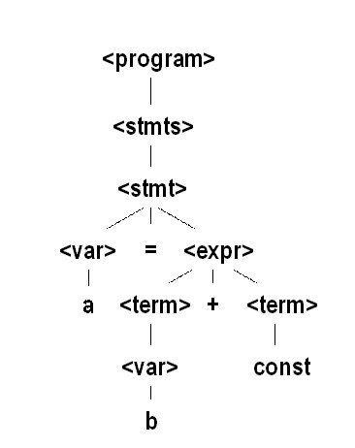

Principles of Programming Language

⇨ a = <term> + <term>

⇨ a = <var> + <term>   
⇨ a = b + <term>   
⇨ a = b + const

Derivation

Every string of symbols in the derivation is a sentential form

A sentence is a sentential form that has only terminal symbols

A leftmost derivation is one in which the leftmost nonterminal in each sentential form is the one that is expanded

A derivation may be neither leftmost nor rightmost

Parse Tree

A hierarchical representation of a derivation

Ambiguity in Grammars

A grammar is ambiguous iff it generates a sentential form that has two or more distinct parse trees

An Ambiguous Expression Grammar

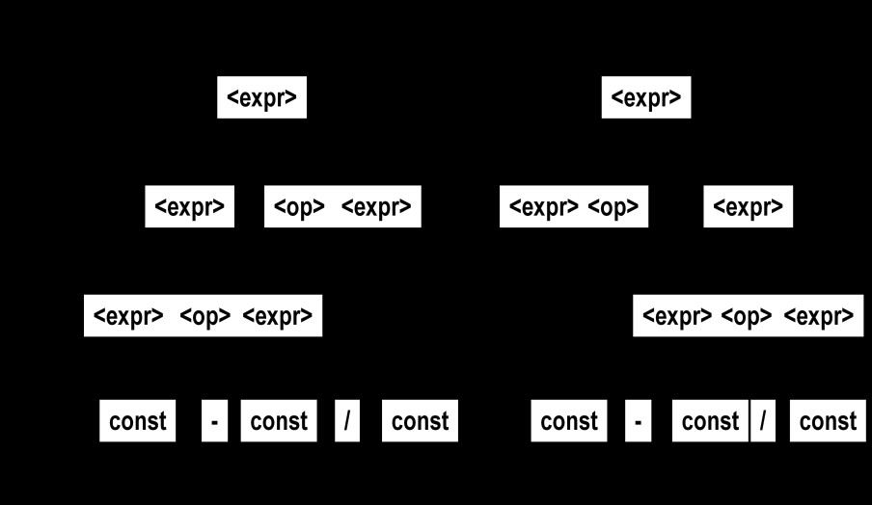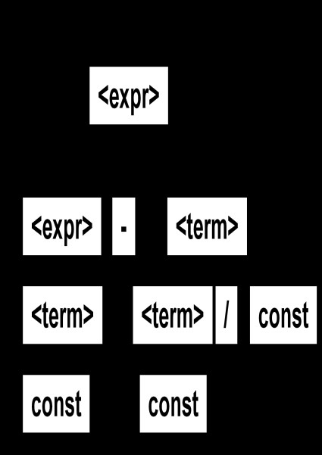

Principles of Programming Language

An Unambiguous Expression Grammar

If we use the parse tree to indicate precedence levels of the operators, we cannot have ambiguity

<expr> <expr> - <term> | <term>

<term> <term> / const| const

Associativity of Operators

Operator associativity can also be indicated by a grammar

<expr> -> <expr> + <expr> | const (ambiguous)   
<expr> -> <expr> + const | const (unambiguous)

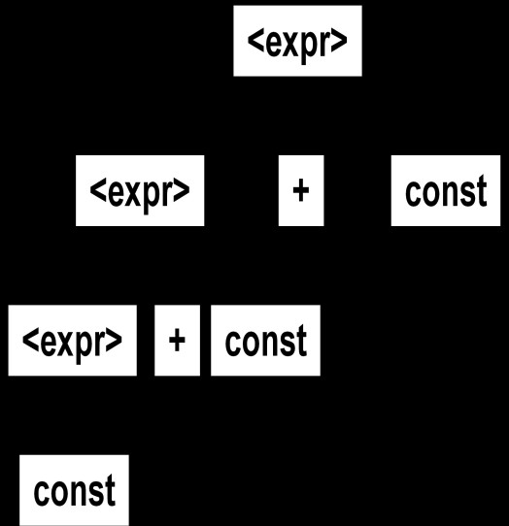

Principles of Programming Language

Extended BNF

Optional parts are placed in brackets ([ ])   
 <proc_call> -> ident [(<expr_list>)]

Alternative parts of RHSs are placed inside parentheses and separated via vertical bars

<term> → <term> (+|-) const

Repetitions (0 or more) are placed inside braces ({ })   
 <ident> → letter {letter|digit}

BNF and EBNF

BNF

<expr> <expr> + <term>

| <expr> - <term>

| <term>

<term> <term> * <factor>

| <term> / <factor>

| <factor>

EBNF

<expr> <term> {(+ | -) <term>}

<term> <factor> {(* | /) <factor>}

2.4 Attribute Grammars

Context-free grammars (CFGs) cannot describe all of the syntax of programming languages

Additions to CFGs to carry some semantic info along parse trees Primary value of attribute grammars (AGs):

o Static semantics specification

o Compiler design (static semantics checking) Attribute Grammars : Definition

An attribute grammar is a context-free grammar G = (S, N, T, P) with the

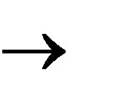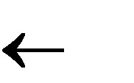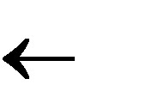

Principles of Programming Language

following additions:

o For each grammar symbol x there is a set A(x) of attribute values

o Each rule has a set of functions that define certain attributes of the   
 nonterminals in the rule

o Each rule has a (possibly empty) set of predicates to check for attribute   
 consistency

o Let X0 X1 ... Xn be a rule

o Functions of the form S(X0) = f(A(X1), ... , A(Xn)) define synthesized   
 attributes

o Functions of the form I(Xj) = f(A(X0), ... , A(Xn)), for i <= j <= n, define   
 inherited attributes

o Initially, there are intrinsic attributes on the leaves Attribute Grammars: Example

Syntax

<assign> -> <var> = <expr>

<expr> -> <var> + <var> | <var> <var> A | B | C

actual_type: synthesized for <var> and <expr> expected_type: inherited for <expr>

Syntax rule: <expr> <var>[1] + <var>[2]

Semantic rules:

<expr>.actual_type <var>[1].actual_type

Predicate:

<var>[1].actual_type == <var>[2].actual_type   
<expr>.expected_type == <expr>.actual_type

Syntax rule: <var> id

Semantic rule:

<var>.actual_type lookup (<var>.string)

How are attribute values computed?

o If all attributes were inherited, the tree could be decorated in top-down   
 order.

o If all attributes were synthesized, the tree could be decorated in bottom-  
 up order.

o In many cases, both kinds of attributes are used, and it is some   
 combination of top-down and bottom-up that must be used.

<expr>.expected_type inherited from parent   
 <var>[1].actual_type lookup (A)



Principles of Programming Language

<var>[2].actual_type lookup (B)

<var>[1].actual_type =? <var>[2].actual_type

<expr>.actual_type <var>[1].actual_type   
<expr>.actual_type =? <expr>.expected_type

2.5 Semantics

There is no single widely acceptable notation or formalism for describing semantics

Operational Semantics

o Describe the meaning of a program by executing its statements on a

machine, either simulated or actual. The change in the state of the

machine (memory, registers, etc.) defines the meaning of the statement   
To use operational semantics for a high-level language, a virtual machine is   
needed

A hardware pure interpreter would be too expensive A software pure interpreter also has problems:

o The detailed characteristics of the particular computer would make   
 actions difficult to understand

o Such a semantic definition would be machine- dependent Operational Semantics

A better alternative: A complete computer simulation The process:

o Build a translator (translates source code to the machine code of an   
 idealized computer)

o Build a simulator for the idealized computer Evaluation of operational semantics:

o Good if used informally (language manuals, etc.)

o Extremely complex if used formally (e.g., VDL), it was used for describing   
 semantics of PL/I.

Axiomatic Semantics

o Based on formal logic (predicate calculus)

o Original purpose: formal program verification

o Approach: Define axioms or inference rules for each statement type in   
 the language (to allow transformations of expressions to other   
 expressions)

o The expressions are called assertions

Axiomatic Semantics

An assertion before a statement (a precondition) states the relationships and constraints among variables that are true at that point in execution   
An assertion following a statement is a postcondition

A weakest precondition is the least restrictive precondition that will guarantee the postcondition

Pre-post form: {P} statement {Q}



Principles of Programming Language

An example: a = b + 1 {a > 1}

One possible precondition: {b > 10}

Weakest precondition: {b > 0}

Program proof process: The postcondition for the whole program is the desired result. Work back through the program to the first statement. If the   
precondition on the first statement is the same as the program spec, the   
program is correct.

An axiom for assignment statements   
(x = E):

{Qx->E} x = E {Q}

An inference rule for sequences

o For a sequence S1;S2:

o {P1} S1 {P2}

o {P2} S2 {P3}

An inference rule for logical pretest loops   
 For the loop construct:

{P} while B do S end {Q}

Characteristics of the loop invariant   
I must meet the following conditions:

o P => I (the loop invariant must be true initially)

o {I} B {I} (evaluation of the Boolean must not

change the validity of I)

o {I and B} S {I} (I is not changed by executing the

body of the loop)

o (I and (not B)) => Q (if I is true and B is false, Q

is implied)

o The loop terminates (this can be difficult to prove)

The loop invariant I is a weakened version of the loop postcondition, and it is also a precondition.

I must be weak enough to be satisfied prior to the beginning of the loop, but

when combined with the loop exit condition, it must be strong enough to force the truth of the postcondition

Evaluation of axiomatic semantics:

o Developing axioms or inference rules for all of the statements in a   
 language is difficult

o It is a good tool for correctness proofs, and an excellent framework for

reasoning about programs, but it is not as useful for language users and compiler writers

o Its usefulness in describing the meaning of a programming language is   
 limited for language users or compiler writers

Denotational Semantics

o Based on recursive function theory



Principles of Programming Language

o The most abstract semantics description method

o Originally developed by Scott and Strachey (1970)

o The process of building a denotational spec for a language (not   
 necessarily easy):

▪ Define a mathematical object for each language entity

▪ Define a function that maps instances of the language entities   
 onto instances of the corresponding mathematical objects

o The meaning of language constructs are defined by only the values of the   
 program's variables

o The difference between denotational and operational semantics: In   
 operational semantics, the state changes are defined by coded   
 algorithms; in denotational semantics, they are defined by rigorous   
 mathematical functions

o The state of a program is the values of all its current variables

s = {<i1, v1>, <i2, v2>, …, <in, vn>}

o Let VARMAP be a function that, when given a variable name and a state,   
 returns the current value of the variable

VARMAP(ij, s) = vj

Decimal Numbers

o The following denotational semantics description maps decimal numbers   
 as strings of symbols into numeric values

<dec_num> 0 | 1 | 2 | 3 | 4 | 5 | 6 | 7 | 8 | 9

⇨ | <dec_num> (0 | 1 | 2 | 3 | 4 |

5 | 6 | 7 | 8 | 9)

Mdec('0') = 0, Mdec ('1') = 1, …, Mdec ('9') = 9

Mdec (<dec_num> '0') = 10 * Mdec (<dec_num>)

Mdec (<dec_num> '1’) = 10 * Mdec (<dec_num>) + 1   
…

Mdec (<dec_num> '9') = 10 * Mdec (<dec_num>) + 9

Expressions

Map expressions onto Z {error}

We assume expressions are decimal numbers, variables, or binary expressions   
having one arithmetic operator and two operands, each of which can be an   
expression

Me(<expr>, s) =   
case <expr> of

<dec_num> => Mdec(<dec_num>, s)   
<var> =>

if VARMAP(<var>, s) == undef   
 then error

else VARMAP(<var>, s) <binary_expr> =>

if (Me(<binary_expr>.<left_expr>, s) == undef



Principles of Programming Language

OR Me(<binary_expr>.<right_expr>, s) =   
 ⇨ undef)

then error   
else

if (<binary_expr>.<operator> == ‗+‘ then   
Me(<binary_expr>.<left_expr>, s) +   
 Me(<binary_expr>.<right_expr>, s) else Me(<binary_expr>.<left_expr>, s) * Me(<binary_expr>.<right_expr>, s)

Assignment Statements

o Maps state sets to state sets

Ma(x := E, s) =

if Me(E, s) == error then error

else s‘ = {<i1‘,v1‘>,<i2‘,v2‘>,...,<in‘,vn‘>},   
 where for j = 1, 2, ..., n,

vj‘ = VARMAP(ij, s) if ij <> x = Me(E, s) if ij == x

Logical Pretest Loops

o Maps state sets to state sets

Ml(while B do L, s) =

if Mb(B, s) == undef then error

else if Mb(B, s) == false   
 then s

else if Msl(L, s) == error   
 then error

else Ml(while B do L, Msl(L, s))

The meaning of the loop is the value of the program variables after the

statements in the loop have been executed the prescribed number of times, assuming there have been no errors

In essence, the loop has been converted from iteration to recursion, where the   
recursive control is mathematically defined by other recursive state mapping   
functions

Recursion, when compared to iteration, is easier to describe with mathematical   
rigor

Evaluation of denotational semantics

o Can be used to prove the correctness of programs

o Provides a rigorous way to think about programs

o Can be an aid to language design

o Has been used in compiler generation systems

o Because of its complexity, they are of little use to language users

Summary



Principles of Programming Language

BNF and context-free grammars are equivalent meta-languages

o Well-suited for describing the syntax of programming languages

An attribute grammar is a descriptive formalism that can describe both the syntax and the semantics of a language

Three primary methods of semantics description

o Operation, axiomatic, denotational

Principles of Programming Language

UNIT-II

Data types

Topics

• Introduction

• Primitive Data Types

• Character String Types

• User-Defined Ordinal Types

• Array Types

• Associative Arrays

• Record Types

• Union Types

• Pointer and Reference Types

• Names

• Variables

• The Concept of Binding

• Type Checking

• Strong Typing

• Type Compatibility

• Scope

• Scope and Lifetime

• Referencing Environments

• Named Constants

Introduction

•A data type defines a collection of data objects and a set of predefined operations on those objects

•A descriptor is the collection of the attributes of a variable

•An object represents an instance of a user-defined (abstract data) type

•One design issue for all data types: What operations are defined and how are they specified?

Principles of Programming Language

Primitive Data Types

•Almost all programming languages provide a set of primitive data types

•Primitive data types: Those not defined in terms of other data types

•Some primitive data types are merely reflections of the hardware

•Others require only a little non-hardware support for their implementation Primitive Data Types: Integer

•Almost always an exact reflection of the hardware so the mapping is trivial

•There may be as many as eight different integer types in a language

•Java‘s signed integer sizes: byte, short, int, long

Primitive Data Types: Floating Point

•Model real numbers, but only as approximations

•Languages for scientific use support at least two floating-point types (e.g., float and double; sometimes more

•Usually exactly like the hardware, but not always

•IEEE Floating-Point

Standard 754

Primitive Data Types: Complex

•Some languages support a complex type, e.g., Fortran and Python

•Each value consists of two floats, the real part and the imaginary part

•Literal form (in Python):

(7 + 3j), where 7 is the real part and 3 is the imaginary part

Primitive Data Types: Decimal

•For business applications (money)

-Essential to COBOL

-C# offers a decimal data type

•Store a fixed number of decimal digits, in coded form (BCD)

•Advantage: accuracy

•Disadvantages: limited range, wastes memory

Primitive Data Types: Boolean

Principles of Programming Language

•Simplest of all

•Range of values: two elements, one for ―true‖ and one for ―false‖

•Could be implemented as bits, but often as bytes

-Advantage: readability

Primitive Data Types: Character

•Stored as numeric codings

•Most commonly used coding: ASCII

•An alternative, 16-bit coding: Unicode

-Includes characters from most natural languages

-Originally used in Java

-C# and JavaScript also support Unicode Character String Types

•Values are sequences of characters

•Design issues:

-Is it a primitive type or just a special kind of array?

-Should the length of strings be static or dynamic? Character String Types Operations

•Typical operations:

-Assignment and copying

-Comparison (=, >, etc.)

-Catenation

-Substring reference

-Pattern matching

Character String Type in Certain Languages

•C and C++

Principles of Programming Language

-Not primitive

-Use char arrays and a library of functions that provide operations

•SNOBOL4 (a string manipulation language)

-Primitive

-Many operations, including elaborate pattern matching

•Fortran and Python

-Primitive type with assignment and several operations

•Java

-Primitive via the String class

•Perl, JavaScript, Ruby, and PHP

- Provide built-in pattern matching, using regular   
 expressions

Character String Length Options

•Static: COBOL, Java‘s String class

•Limited Dynamic Length: C and C++

-In these languages, a special character is used to indicate the end of a string‘s characters, rather than maintaining the length

•Dynamic (no maximum): SNOBOL4, Perl, JavaScript

•Ada supports all three string length options Character String Type Evaluation

•Aid to writability

•As a primitive type with static length, they are inexpensive to provide--why not have them?

•Dynamic length is nice, but is it worth the expense? Character String Implementation

•Static length: compile-time descriptor

•Limited dynamic length: may need a run-time descriptor for length (but not in C and C++)

•Dynamic length: need run-time descriptor; allocation/de-allocation is the biggest implementation problem

Principles of Programming Language

Compile- and Run-Time Descriptors

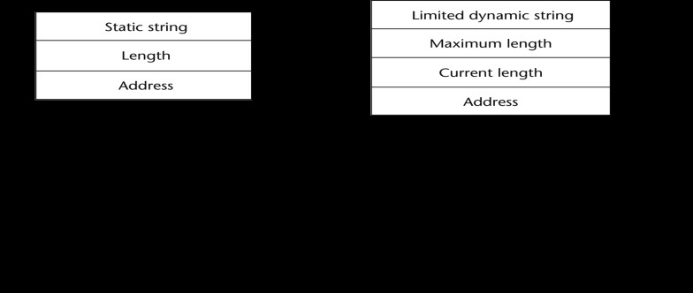

User-Defined Ordinal Types

•An ordinal type is one in which the range of possible values can be easily associated with the set of positive integers

•Examples of primitive ordinal types in Java

-integer

-char

-boolean

Enumeration Types

•All possible values, which are named constants, are provided in the definition

•C# example

enum days {mon, tue, wed, thu, fri, sat, sun};

•Design issues

-Is an enumeration constant allowed to appear in more than one type   
definition, and if so, how is the type of an occurrence of that constant   
checked?

Principles of Programming Language

-Are enumeration values coerced to integer?

-Any other type coerced to an enumeration type? Evaluation of Enumerated Type

•Aid to readability, e.g., no need to code a color as a number

•Aid to reliability, e.g., compiler can check:

-operations (don‘t allow colors to be added)

-No enumeration variable can be assigned a value outside its defined   
range

-Ada, C#, and Java 5.0 provide better support for enumeration than C++ because enumeration type variables in these languages are not coerced into integer types

Subrange Types

•An ordered contiguous subsequence of an ordinal type

-Example: 12..18 is a subrange of integer type

•Ada‘s design

type Days is (mon, tue, wed, thu, fri, sat, sun); subtype Weekdays is Days range mon..fri;   
subtype Index is Integer range 1..100;

Day1: Days;

Day2: Weekday;   
Day2 := Day1;

Subrange Evaluation

•Aid to readability

-Make it clear to the readers that variables of subrange can store only certain range of values

•Reliability

-Assigning a value to a subrange variable that is outside the specified range is detected as an error

Implementation of User-Defined Ordinal Types

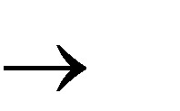

Principles of Programming Language

•Enumeration types are implemented as integers

•Subrange types are implemented like the parent types with code inserted (by the compiler) to restrict assignments to subrange variables

Array Types

•An array is an aggregate of homogeneous data elements in which an individual element is identified by its position in the aggregate, relative to the first element.

Array Design Issues

•What types are legal for subscripts?

•Are subscripting expressions in element references range checked?

•When are subscript ranges bound?

•When does allocation take place?

•What is the maximum number of subscripts?

•Can array objects be initialized?

•Are any kind of slices supported? Array Indexing

•Indexing (or subscripting) is a mapping from indices to elements   
 array_name (index_value_list) an element

•Index Syntax

-FORTRAN, PL/I, Ada use parentheses

•Ada explicitly uses parentheses to show uniformity between array references and function calls because both are mappings

-Most other languages use brackets Arrays Index (Subscript) Types

•FORTRAN, C: integer only

•Ada: integer or enumeration (includes Boolean and char)

•Java: integer types only

•Index range checking

Principles of Programming Language

- C, C++, Perl, and Fortran do not specify   
 range checking

- Java, ML, C# specify range checking

- In Ada, the default is to require range   
 checking, but it can be turned off

Subscript Binding and Array Categories

•

Static: subscript ranges are statically bound and storage allocation is static

(before run-time)

-Advantage: efficiency (no dynamic allocation)

•Fixed stack-dynamic: subscript ranges are statically bound, but the allocation is done at declaration time

-Advantage: space efficiency

•Stack-dynamic: subscript ranges are dynamically bound and the storage allocation is dynamic (done at run-time)

-Advantage: flexibility (the size of an array need not be known until the array is to be used)

•Fixed heap-dynamic: similar to fixed stack-dynamic: storage binding is dynamic but fixed after allocation (i.e., binding is done when requested and storage is allocated from heap, not stack)

Subscript Binding and Array Categories (continued)

•Heap-dynamic: binding of subscript ranges and storage allocation is dynamic and can change any number of times

-Advantage: flexibility (arrays can grow or shrink during program execution)

•C and C++ arrays that include static modifier are static

•C and C++ arrays without static modifier are fixed stack-dynamic

•C and C++ provide fixed heap-dynamic arrays

•C# includes a second array class ArrayList that provides fixed heap-dynamic

•Perl, JavaScript, Python, and Ruby support heap-dynamic arrays Array Initialization

•Some language allow initialization at the time of storage allocation

Principles of Programming Language

-C, C++, Java, C# example

int list [] = {4, 5, 7, 83}

-Character strings in C and C++ char name [] = ―freddie‖;

-Arrays of strings in C and C++

char *names [] = {―Bob‖, ―Jake‖, ―Joe‖];

-Java initialization of String objects   
String[] names = {―Bob‖, ―Jake‖, ―Joe‖};

Heterogeneous Arrays

•A heterogeneous array is one in which the elements need not be of the same   
type

•Supported by Perl, Python, JavaScript, and Ruby Arrays Operations

•APL provides the most powerful array processing operations for vectors and   
matrixes as well as unary operators (for example, to reverse column elements)

•Ada allows array assignment but also catenation

•Python‘s array assignments, but they are only reference changes. Python also supports array catenation and element membership operations

•Ruby also provides array catenation

•Fortran provides elemental operations because they are between pairs of array elements

-For example, + operator between two arrays results in an array of the sums of the element pairs of the two arrays

Rectangular and Jagged Arrays

•A rectangular array is a multi-dimensioned array in which all of the rows   
have the same number of elements and all columns have the same number of   
elements

•A jagged matrix has rows with varying number of elements

-Possible when multi-dimensioned arrays actually appear as arrays of arrays

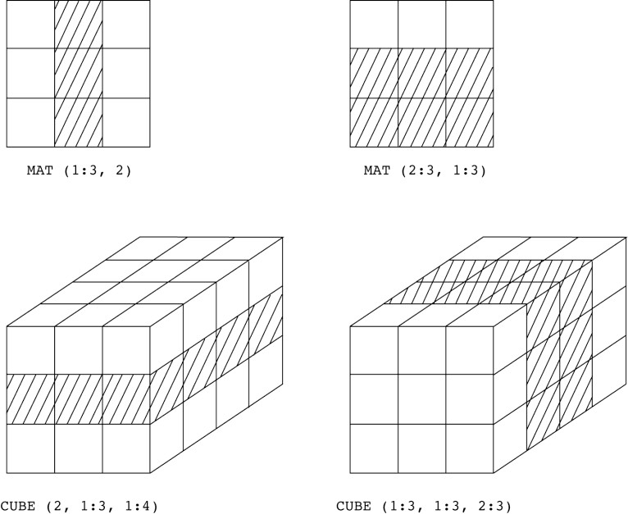

Principles of Programming Language

•C, C++, and Java support jagged arrays

•Fortran, Ada, and C# support rectangular arrays (C# also supports jagged   
arrays)

Slices

•A slice is some substructure of an array; nothing more than a referencing mechanism

•Slices are only useful in languages that have array operations Slice Examples

•Fortran 95

Integer, Dimension (10) :: Vector   
Integer, Dimension (3, 3) :: Mat   
Integer, Dimension (3, 3) :: Cube

Vector (3:6) is a four element array

Slices Examples in Fortran 95

Implementation of Arrays

•Access function maps subscript expressions to an address in the array

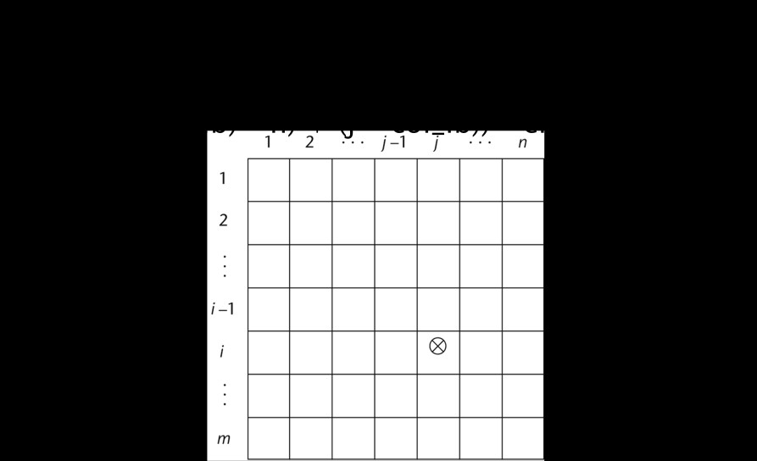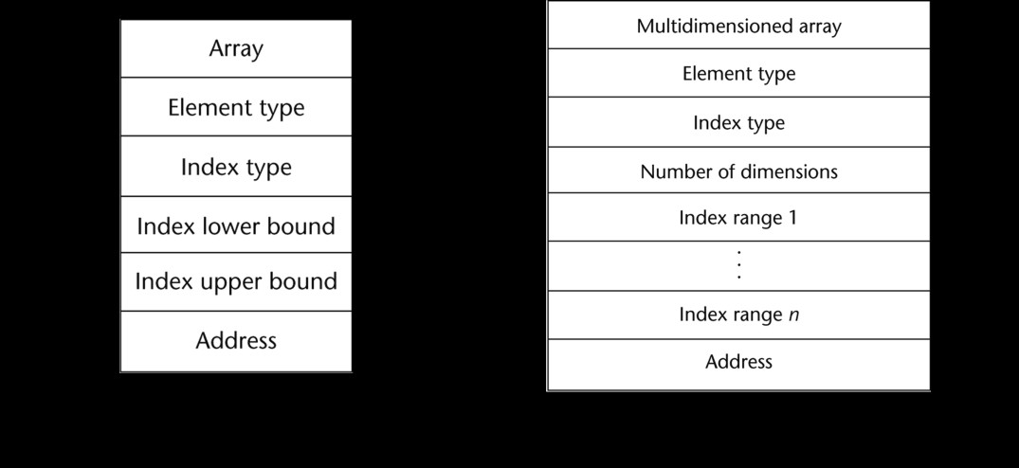

Principles of Programming Language

•Access function for single-dimensioned arrays:   
 address(list[k]) = address (list[lower_bound])

+ ((k-lower_bound) * element_size)

Accessing Multi-dimensioned Arrays

•Two common ways:

-Row major order (by rows) - used in most languages

-column major order (by columns) - used in Fortran

Locating an Element in a Multi-dimensioned Array

Compile-Time Descriptors

Principles of Programming Language

Associative Arrays

•An associative array is an unordered collection of data elements that are indexed by an equal number of values called keys

-User-defined keys must be stored

•Design issues:

- What is the form of references to elements?

- Is the size static or dynamic?

Associative Arrays in Perl

•Names begin with %; literals are delimited by parentheses   
%hi_temps = ("Mon" => 77, "Tue" => 79, ―Wed‖ => 65, …);

•Subscripting is done using braces and keys $hi_temps{"Wed"} = 83;

-Elements can be removed with delete   
 delete $hi_temps{"Tue"};

Record Types

•A record is a possibly heterogeneous aggregate of data elements in which the individual elements are identified by names

•Design issues:

-What is the syntactic form of references to the field?

-Are elliptical references allowed

Definition of Records in COBOL

•COBOL uses level numbers to show nested records; others use recursive definition

01 EMP-REC.

02 EMP-NAME.

05 FIRST PIC X(20).

05 MID PIC X(10).

05 LAST PIC X(20).

02 HOURLY-RATE PIC 99V99.

Definition of Records in Ada

•Record structures are indicated in an orthogonal way

Principles of Programming Language

type Emp_Rec_Type is record

First: String (1..20);

Mid: String (1..10);   
 Last: String (1..20);   
 Hourly_Rate: Float; end record;

Emp_Rec: Emp_Rec_Type;

References to Records

•Record field references

1. COBOL

field_name OF record_name_1 OF ... OF record_name_n

2. Others (dot notation)

record_name_1.record_name_2 record_name_n.field_name

•Fully qualified references must include all record names

•Elliptical references allow leaving out record names as long as the reference is unambiguous, for example in COBOL

FIRST, FIRST OF EMP-NAME, and FIRST of EMP-REC are elliptical references to the employee‘s first name

Operations on Records

•Assignment is very common if the types are identical

•Ada allows record comparison

•Ada records can be initialized with aggregate literals

•COBOL provides MOVE CORRESPONDING

-Copies a field of the source record to the corresponding field in the target   
record

Evaluation and Comparison to Arrays

•Records are used when collection of data values is heterogeneous

•Access to array elements is much slower than access to record fields, because subscripts are dynamic (field names are static)

•Dynamic subscripts could be used with record field access, but it would disallow type checking and it would be much slower

Implementation of Record Type

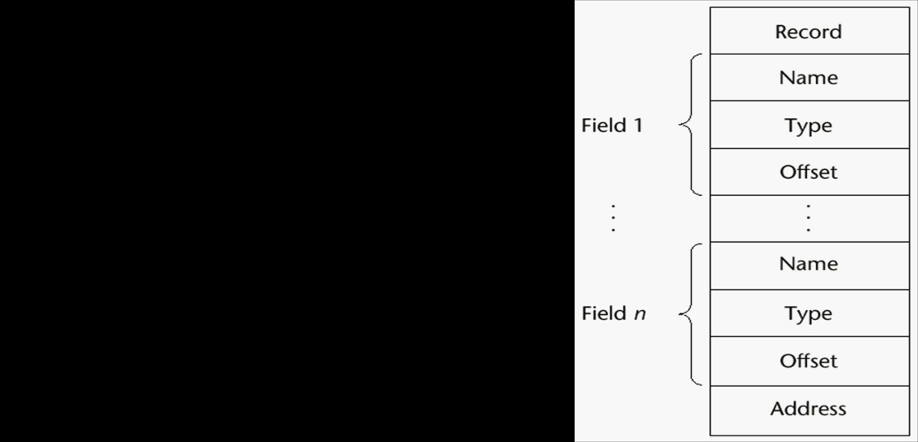

Principles of Programming Language

Unions Types

•A union is a type whose variables are allowed to store different type values at different times during execution

•Design issues

-Should type checking be required?

-Should unions be embedded in records? Discriminated vs. Free Unions

•Fortran, C, and C++ provide union constructs in which there is no language support for type checking; the union in these languages is called free union

•Type checking of unions require that each union include a type indicator called a discriminant

-Supported by Ada

Ada Union Types

type Shape is (Circle, Triangle, Rectangle);   
type Colors is (Red, Green, Blue);   
type Figure (Form: Shape) is record   
 Filled: Boolean;

Color: Colors;   
case Form is

when Circle => Diameter: Float; when Triangle =>

Leftside, Rightside: Integer; Angle: Float;

when Rectangle => Side1, Side2: Integer;

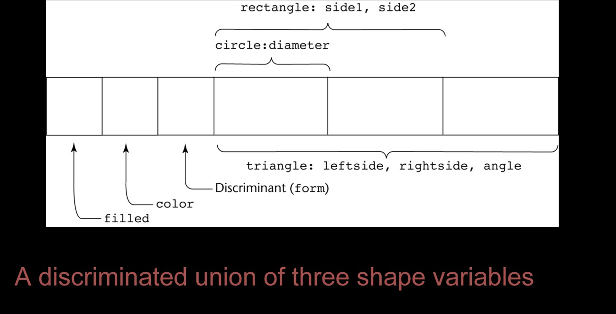

Principles of Programming Language

end case;

end record;

Ada Union Type Illustrated

Evaluation of Unions

•Free unions are unsafe

-Do not allow type checking

•Java and C# do not support unions

-Reflective of growing concerns for safety in programming language

•Ada‘s descriminated unions are safe

Pointer and Reference Types

•A pointer type variable has a range of values that consists of memory addresses and a special value, nil

•Provide the power of indirect addressing

•Provide a way to manage dynamic memory

•A pointer can be used to access a location in the area where storage is dynamically created (usually called a heap)

Design Issues of Pointers

•What are the scope of and lifetime of a pointer variable?

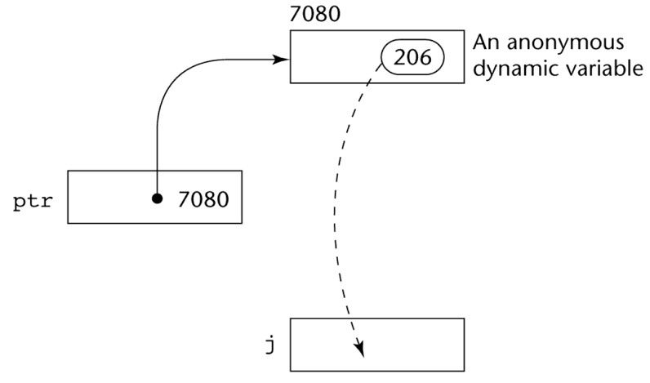

Principles of Programming Language

•What is the lifetime of a heap-dynamic variable?

•Are pointers restricted as to the type of value to which they can point?

•Are pointers used for dynamic storage management, indirect addressing, or   
both?

•Should the language support pointer types, reference types, or both? Pointer Operations

•Two fundamental operations: assignment and dereferencing

•Assignment is used to set a pointer variable‘s value to some useful address

•Dereferencing yields the value stored at the location represented by the pointer‘s value

-Dereferencing can be explicit or implicit

-C++ uses an explicit operation via *   
 j = *ptr

sets j to the value located at ptr

Pointer Assignment Illustrated

The assignment operation j = *ptr

Problems with Pointers

•Dangling pointers (dangerous)

-A pointer points to a heap-dynamic variable that has been deallocated

•Lost heap-dynamic variable

-An allocated heap-dynamic variable that is no longer accessible to the user

Principles of Programming Language

program (often called garbage)

•Pointer p1 is set to point to a newly created heap-dynamic variable

•Pointer p1 is later set to point to another newly created heap-dynamic   
variable

•The process of losing heap-dynamic variables is called memory leakage Pointers in Ada

•Some dangling pointers are disallowed because dynamic objects can be automatically deallocated at the end of pointer's type scope

•The lost heap-dynamic variable problem is not eliminated by Ada (possible with UNCHECKED_DEALLOCATION)

Pointers in C and C++

•Extremely flexible but must be used with care

•Pointers can point at any variable regardless of when or where it was allocated

•Used for dynamic storage management and addressing

•Pointer arithmetic is possible

•Explicit dereferencing and address-of operators

•Domain type need not be fixed (void *)

void * can point to any type and can be type checked (cannot be de-referenced)

Pointer Arithmetic in C and C++

float stuff[100];

float *p;

p = stuff;

*(p+5) is equivalent to stuff[5] and p[5]

*(p+i) is equivalent to stuff[i] and p[i]

Reference Types

•C++ includes a special kind of pointer type called a reference type that is used primarily for formal parameters

Principles of Programming Language

-Advantages of both pass-by-reference and pass-by-value

•Java extends C++‘s reference variables and allows them to replace pointers   
entirely

-References are references to objects, rather than being addresses

•C# includes both the references of Java and the pointers of C++ Evaluation of Pointers

•Dangling pointers and dangling objects are problems as is heap management

•Pointers are like goto's--they widen the range of cells that can be accessed by a variable

•Pointers or references are necessary for dynamic data structures--so we can't design a language without them

Representations of Pointers

•Large computers use single values

•Intel microprocessors use segment and offset Dangling Pointer Problem

•Tombstone: extra heap cell that is a pointer to the heap-dynamic variable

-The actual pointer variable points only at tombstones

-When heap-dynamic variable de-allocated, tombstone remains but set to nil

-Costly in time and space

. Locks-and-keys: Pointer values are represented as (key, address) pairs

-Heap-dynamic variables are represented as variable plus cell for integer lock   
value

-When heap-dynamic variable allocated, lock value is created and placed in lock cell and key cell of pointer

Heap Management

•A very complex run-time process

•Single-size cells vs. variable-size cells

•Two approaches to reclaim garbage

Principles of Programming Language

-Reference counters (eager approach): reclamation is gradual

-Mark-sweep (lazy approach): reclamation occurs when the list of variable space becomes empty

Reference Counter

•Reference counters: maintain a counter in every cell that store the number of pointers currently pointing at the cell

-Disadvantages: space required, execution time required, complications for cells connected circularly

-Advantage: it is intrinsically incremental, so significant delays in the application execution are avoided

Mark-Sweep

•The run-time system allocates storage cells as requested and disconnects pointers from cells as necessary; mark-sweep then begins

-Every heap cell has an extra bit used by collection algorithm

-All cells initially set to garbage

-All pointers traced into heap, and reachable cells marked as not garbage

-All garbage cells returned to list of available cells

-Disadvantages: in its original form, it was done too infrequently. When done,   
it caused significant delays in application execution. Contemporary mark-  
sweep algorithms avoid this by doing it more often—called incremental mark-  
sweep

Marking Algorithm

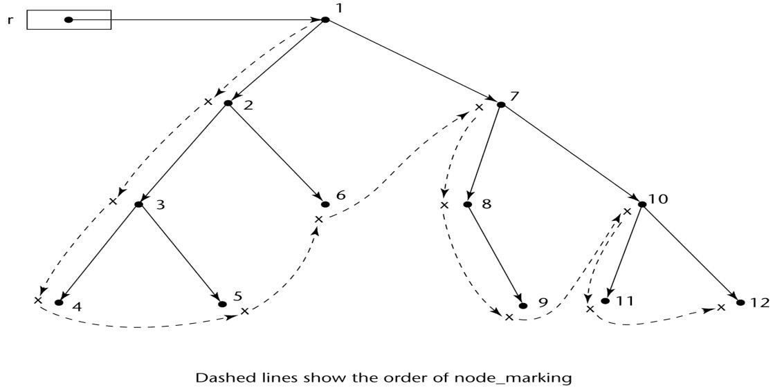

Principles of Programming Language

Variable-Size Cells

•All the difficulties of single-size cells plus more

•Required by most programming languages

•If mark-sweep is used, additional problems occur

-The initial setting of the indicators of all cells in the heap is difficult

-The marking process in nontrivial

-Maintaining the list of available space is another source of overhead

Names

 Design issues for names:   
  Maximum length?

 Are connector characters allowed?  Are names case sensitive?

 Are special words reserved words or keywords?

 Length

 If too short, they cannot be connotative  Language examples:

 FORTRAN I: maximum 6   
 COBOL: maximum 30

 FORTRAN 90 and ANSI C: maximum 31

 Ada and Java: no limit, and all are significant

 C++: no limit, but implementors often impose one  Connectors

 Pascal, Modula-2, and FORTRAN 77 don't allow

Principles of Programming Language

 Others do

 Case sensitivity

 Disadvantage: readability (names that look alike are different)

 worse in C++ and Java because predefined names are mixed case (e.g.   
 IndexOutOfBoundsException)

 C, C++, and Java names are case sensitive   
  The names in other languages are not  Special words

 An aid to readability; used to delimit or separate statement clauses

 Def: A keyword is a word that is special only in certain contexts i.e. in Fortran:   
 Real VarName (Real is data type followed with a name, therefore Real is a keyword)   
 Real = 3.4 (Real is a variable)

 Disadvantage: poor readability

 Def: A reserved word is a special word that cannot be used as a user-defined   
 name

Variables

 A variable is an abstraction of a memory cell

 Variables can be characterized as a sextuple of attributes:   
 (name, address, value, type, lifetime, and scope)   
 Name - not all variables have them (anonymous)

 Address - the memory address with which it is associated (also called l-value)

 A variable may have different addresses at different times during execution

 A variable may have different addresses at different places in a program

 If two variable names can be used to access the same memory location, they are   
 called aliases

 Aliases are harmful to readability (program readers must remember all of them)  How aliases can be created:

 Pointers, reference variables, C and C++ unions, (and through parameters -  
 discussed in Chapter 9)

 Some of the original justifications for aliases are no longer valid; e.g. memory   
 reuse in FORTRAN

 Replace them with dynamic allocation

 Type - determines the range of values of variables and the set of operations that are   
 defined for values of that type; in the case of floating point, type also determines the   
 precision

 Value - the contents of the location with which the variable is associated

 Abstract memory cell - the physical cell or collection of cells associated with a   
 variable

The Concept of Binding

 The l-value of a variable is its address

Principles of Programming Language

 The r-value of a variable is its value

 Def: A binding is an association, such as between an attribute and an entity, or   
 between an operation and a symbol

 Def: Binding time is the time at which a binding takes place.  Possible binding times:

 Language design time--e.g., bind operator symbols to operations  Language implementation time--e.g., bind floating point type to a   
 representation

 Compile time--e.g., bind a variable to a type in C or Java

 Load time--e.g., bind a FORTRAN 77 variable to a memory cell (or a C static   
 variable)

 Runtime--e.g., bind a nonstatic local variable to a memory cell

 Def: A binding is static if it first occurs before run time and remains unchanged   
 throughout program execution.

 Def: A binding is dynamic if it first occurs during execution or can change during   
 execution of the program.

 Type Bindings

 How is a type specified?

 When does the binding take place?

 If static, the type may be specified by either an explicit or an implicit declaration   
 Def: An explicit declaration is a program statement used for declaring the types of   
 variables

 Def: An implicit declaration is a default mechanism for specifying types of variables   
 (the first appearance of the variable in the program)

 FORTRAN, PL/I, BASIC, and Perl provide implicit declarations   
  Advantage: writability

 Disadvantage: reliability (less trouble with Perl)

 Dynamic Type Binding (JavaScript and PHP)

 Specified through an assignment statement e.g., JavaScript

list = [2, 4.33, 6, 8];

list = 17.3;

 Advantage: flexibility (generic program units)  Disadvantages:

 High cost (dynamic type checking and interpretation)   
  Type error detection by the compiler is difficult   
 Type Inferencing (ML, Miranda, and Haskell)

 Rather than by assignment statement, types are determined from the context of   
 the reference

 Storage Bindings & Lifetime

 Allocation - getting a cell from some pool of available cells  Deallocation - putting a cell back into the pool

 Def: The lifetime of a variable is the time during which it is bound to a particular   
 memory cell

Principles of Programming Language

 Categories of variables by lifetimes

 Static--bound to memory cells before execution begins and remains bound to   
 the same memory cell throughout execution.

e.g. all FORTRAN 77 variables, C static variables

 Advantages: efficiency (direct addressing), history-sensitive subprogram   
 support

 Disadvantage: lack of flexibility (no recursion)  Categories of variables by lifetimes

 Stack-dynamic--Storage bindings are created for variables when their   
 declaration statements are elaborated.

 If scalar, all attributes except address are statically bound

 e.g. local variables in C subprograms and Java methods

 Advantage: allows recursion; conserves storage  Disadvantages:

 Overhead of allocation and deallocation   
  Subprograms cannot be history sensitive   
  Inefficient references (indirect addressing)  Categories of variables by lifetimes

 Explicit heap-dynamic--Allocated and deallocated by explicit directives,   
 specified by the programmer, which take effect during execution   
 Referenced only through pointers or references   
 e.g. dynamic objects in C++ (via new and delete)   
 all objects in Java

 Advantage: provides for dynamic storage management  Disadvantage: inefficient and unreliable

 Categories of variables by lifetimes

 Implicit heap-dynamic--Allocation and deallocation caused by assignment   
 statements

e.g. all variables in APL; all strings and arrays in Perl and JavaScript  Advantage: flexibility

 Disadvantages:

 Inefficient, because all attributes are dynamic  Loss of error detection

Type Checking

 Generalize the concept of operands and operators to include subprograms and   
 assignments

 Type checking is the activity of ensuring that the operands of an operator are of   
 compatible types

 A compatible type is one that is either legal for the operator, or is allowed under   
 language rules to be implicitly converted, by compiler- generated code, to a legal   
 type. This automatic conversion is called a coercion.

 A type error is the application of an operator to an operand of an inappropriate

Principles of Programming Language

type

 If all type bindings are static, nearly all type checking can be static

 If type bindings are dynamic, type checking must be dynamic

 Def: A programming language is strongly typed if type errors are always detected

Strong Typing

 Advantage of strong typing: allows the detection of the misuses of variables that   
 result in type errors

 Language examples:

 FORTRAN 77 is not: parameters, EQUIVALENCE  Pascal is not: variant records

 C and C++ are not: parameter type checking can be avoided; unions are not   
 type checked

 Ada is, almost (UNCHECKED CONVERSION is loophole)   
 (Java is similar)

 Coercion rules strongly affect strong typing--they can weaken it considerably (C++   
 versus Ada)

 Although Java has just half the assignment coercions of C++, its strong typing is   
 still far less effective than that of Ada

Type Compatibility

 Our concern is primarily for structured types

 Def: Name type compatibility means the two variables have compatible types if   
 they are in either the same declaration or in declarations that use the same type   
 name

 Easy to implement but highly restrictive:

 Subranges of integer types are not compatible with integer types

 Formal parameters must be the same type as their corresponding actual   
 parameters (Pascal)

 Structure type compatibility means that two variables have compatible types if their   
 types have identical structures

 More flexible, but harder to implement

 Consider the problem of two structured types:

 Are two record types compatible if they are structurally the same but use   
 different field names?

 Are two array types compatible if they are the same except that the subscripts   
 are different?

(e.g. [1..10] and [0..9])

 Are two enumeration types compatible if their components are spelled   
 differently?

 With structural type compatibility, you cannot differentiate between types of   
 the same structure (e.g. different units of speed, both float)

Principles of Programming Language

 Language examples:

 Pascal: usually structure, but in some cases name is used (formal parameters)  C: structure, except for records

 Ada: restricted form of name

 Derived types allow types with the same structure to be different  Anonymous types are all unique, even in:

A, B : array (1..10) of INTEGER:

Scope

 The scope of a variable is the range of statements over which it is visible

 The nonlocal variables of a program unit are those that are visible but not declared   
 there

 The scope rules of a language determine how references to names are associated   
 with variables

 Static scope

 Based on program text

 To connect a name reference to a variable, you (or the compiler) must find the   
 declaration

 Search process: search declarations, first locally, then in increasingly larger   
 enclosing scopes, until one is found for the given name

 Enclosing static scopes (to a specific scope) are called its static ancestors; the   
 nearest static ancestor is called a static parent

 Variables can be hidden from a unit by having a "closer" variable with the same   
 name

 C++ and Ada allow access to these "hidden" variables   
  In Ada: unit.name

 In C++: class_name::name  Blocks

 A method of creating static scopes inside program units--from ALGOL 60  Examples:

C and C++: for (...)   
 {

int index;

}

Ada: declare LCL : FLOAT;   
 begin

end

 Evaluation of Static Scoping

 Consider the example:

Assume MAIN calls A and B   
 A calls C and D

B calls A and E

Static Scope Example

Principles of Programming Language

Static Scope Example

Static Scope

 Suppose the spec is changed so that D must now access some data in B  Solutions:

 Put D in B (but then C can no longer call it and D cannot access A's variables)

 Move the data from B that D needs to MAIN (but then all procedures can access   
 them)

 Same problem for procedure access

 Overall: static scoping often encourages many globals  Dynamic Scope

 Based on calling sequences of program units, not their textual layout (temporal   
 versus spatial)

 References to variables are connected to declarations by searching back through   
 the chain of subprogram calls that forced execution to this point   
Scope Example

MAIN

- declaration of x   
 SUB1

- declaration of x -

call SUB2

SUB2

- reference to x -

call SUB1

…

Scope Example

 Static scoping

 Reference to x is to MAIN's x  Dynamic scoping

 Reference to x is to SUB1's x   
 Evaluation of Dynamic Scoping:   
  Advantage: convenience   
  Disadvantage: poor readability

Scope and Lifetime

 Scope and lifetime are sometimes closely related, but are different concepts  Consider a static variable in a C or C++ function

Principles of Programming Language

Referencing Environments

 Def: The referencing environment of a statement is the collection of all names that   
 are visible in the statement

 In a static-scoped language, it is the local variables plus all of the visible variables in   
 all of the enclosing scopes

 A subprogram is active if its execution has begun but has not yet terminated

 In a dynamic-scoped language, the referencing environment is the local variables   
 plus all visible variables in all active subprograms

Named Constants

 Def: A named constant is a variable that is bound to a value only when it is bound   
 to storage

 Advantages: readability and modifiability  Used to parameterize programs

 The binding of values to named constants can be either static (called manifest   
 constants) or dynamic

 Languages:

 Pascal: literals only

 FORTRAN 90: constant-valued expressions   
  Ada, C++, and Java: expressions of any kind Variable Initialization

 Def: The binding of a variable to a value at the time it is bound to storage is called   
 initialization

 Initialization is often done on the declaration statement   
e.g., Java

int sum = 0;

Summary

• The data types of a language are a large part of what determines that   
 language‘s style and usefulness

• The primitive data types of most imperative languages include numeric,   
 character, and Boolean types

• The user-defined enumeration and subrange types are convenient and   
 add to the readability and reliability of programs

• Arrays and records are included in most languages

• Pointers are used for addressing flexibility and to control dynamic   
 storage management

 Case sensitivity and the relationship of names to special words represent design

Principles of Programming Language

issues of names

 Variables are characterized by the sextuples: name, address, value, type, lifetime,

scope

 Binding is the association of attributes with program entities

 Scalar variables are categorized as: static, stack dynamic, explicit heap dynamic,

implicit heap dynamic

 Strong typing means detecting all type errors

Principles of Programming Language

Expressions and Statements

•Introduction

•Arithmetic Expressions

•Overloaded Operators

•Type Conversions

•Relational and Boolean Expressions

•Short-Circuit Evaluation

•Assignment Statements

•Mixed-Mode Assignment

•Control Structures

•Introduction

•Selection Statements

•Iterative Statements

•Unconditional Branching

•Guarded Commands

•Conclusions

Introduction

•Expressions are the fundamental means of specifying computations in a programming language

•To understand expression evaluation, need to be familiar with the orders of operator and operand evaluation

•Essence of imperative languages is dominant role of assignment statements Arithmetic Expressions

•Arithmetic evaluation was one of the motivations for the development of the first programming languages

•Arithmetic expressions consist of operators, operands, parentheses, and function calls

Arithmetic Expressions: Design Issues

•Design issues for arithmetic expressions

Principles of Programming Language

-Operator precedence rules?

-Operator associativity rules?

-Order of operand evaluation?

-Operand evaluation side effects?

-Operator overloading?

-Type mixing in expressions?

Arithmetic Expressions: Operators

•A unary operator has one operand

•A binary operator has two operands

•A ternary operator has three operands

Arithmetic Expressions: Operator Precedence Rules

•The operator precedence rules for expression evaluation define the order in which ―adjacent‖ operators of different precedence levels are evaluated

•Typical precedence levels

- parentheses

- unary operators

- ** (if the language supports it)

- *, /

- +, -

Arithmetic Expressions: Operator Associativity Rule

•The operator associativity rules for expression evaluation define the order in which adjacent operators with the same precedence level are evaluated

•Typical associativity rules

-Left to right, except **, which is right to left

-Sometimes unary operators associate right to left (e.g., in FORTRAN)

•APL is different; all operators have equal precedence and all operators associate right to left

Principles of Programming Language

•Precedence and associativity rules can be overriden with parentheses Arithmetic Expressions: Conditional Expressions

•Conditional Expressions

-C-based languages (e.g., C, C++)

-An example:

average = (count == 0)? 0 : sum / count

-Evaluates as if written like

if (count == 0)

average = 0   
 else

average = sum /count

Arithmetic Expressions: Operand Evaluation Order

•Operand evaluation order

•Variables: fetch the value from memory

•Constants: sometimes a fetch from memory; sometimes the constant is in the machine language instruction

•Parenthesized expressions: evaluate all operands and operators first

•The most interesting case is when an operand is a function call Arithmetic Expressions: Potentials for Side Effects

•Functional side effects: when a function changes a two-way parameter or a non-local variable

•Problem with functional side effects:

-When a function referenced in an expression alters another operand of the expression; e.g., for a parameter change:

a = 10;

/* assume that fun changes its parameter */ b = a + fun(a);

Functional Side Effects

•Two possible solutions to the problem

•Write the language definition to disallow functional side effects

Principles of Programming Language

•No two-way parameters in functions

•No non-local references in functions

•Advantage: it works!

•Disadvantage: inflexibility of one-way parameters and lack of non-local references

•Write the language definition to demand that operand evaluation order be   
fixed

•Disadvantage: limits some compiler optimizations

•Java requires that operands appear to be evaluated in left-to-right order Overloaded Operators

•Use of an operator for more than one purpose is called operator overloading

•Some are common (e.g., + for int and float)

•Some are potential trouble (e.g., * in C and C++)

-Loss of compiler error detection (omission of an operand should be a detectable error)

-Some loss of readability

-Can be avoided by introduction of new symbols (e.g., Pascal‘s div for integer   
division)

Overloaded Operators (continued)

•C++, Ada, Fortran 95, and C# allow user-defined overloaded operators

•Potential problems:

-Users can define nonsense operations

-Readability may suffer, even when the operators make sense Type Conversions

•A narrowing conversion is one that converts an object to a type that cannot include all of the values of the original type e.g., float to int

•A widening conversion is one in which an object is converted to a type that can include at least approximations to all of the values of the original type e.g., int to float

Type Conversions: Mixed Mode

Principles of Programming Language

•A mixed-mode expression is one that has operands of different types

•A coercion is an implicit type conversion

•Disadvantage of coercions:

-They decrease in the type error detection ability of the compiler

•In most languages, all numeric types are coerced in expressions, using widening conversions

•In Ada, there are virtually no coercions in expressions Explicit Type Conversions

•Called casting in C-based languages

•Examples

-C: (int)angle

-Ada: Float (Sum)

Note that Ada’s syntax is similar to that of function calls

Type Conversions: Errors in Expressions

•Causes

-Inherent limitations of arithmetic

-Limitations of computer arithmetic

• Often ignored by the run-time system Relational and Boolean Expressions

•Relational Expressions

e.g., division by zero e.g. overflow

-Use relational operators and operands of various types

-Evaluate to some Boolean representation

-Operator symbols used vary somewhat among languages (!=, /=, .NE., <>, #)

•JavaScript and PHP have two additional relational operator, === and !==

- Similar to their cousins, == and !=, except that they do not coerce their operands

•Boolean Expressions

Principles of Programming Language

-Operands are Boolean and the result is Boolean

-Example operators

FORTRAN 77 FORTRAN 90 C Ada

.AND. and && and

.OR. or || or

.NOT. not ! not

xor

Relational and Boolean Expressions: No Boolean Type in C

•C89 has no Boolean type--it uses int type with 0 for false and nonzero for   
true

•One odd characteristic of C‘s expressions: a < b < c is a legal

expression, but the result is not what you might expect:

-Left operator is evaluated, producing 0 or 1

-The evaluation result is then compared with the third operand (i.e., c) Short Circuit Evaluation

•An expression in which the result is determined without evaluating all of the operands and/or operators

•Example: (13*a) * (b/13-1)

If a is zero, there is no need to evaluate (b/13-1)

•Problem with non-short-circuit evaluation index = 1;

while (index <= length) && (LIST[index] != value)   
 index++;

-When index=length, LIST [index] will cause an indexing problem (assuming LIST has length -1 elements)

Short Circuit Evaluation (continued)

•C, C++, and Java: use short-circuit evaluation for the usual Boolean operators (&& and ||), but also provide bitwise Boolean operators that are not short circuit (& and |)

•Ada: programmer can specify either (short-circuit is specified with and then and or else)

•Short-circuit evaluation exposes the potential problem of side effects in expressions

e.g. (a > b) || (b++ / 3)

Principles of Programming Language

Assignment Statements1

•The general syntax

<target_var> <assign_operator> <expression>

•The assignment operator

= FORTRAN, BASIC, the C-based languages := ALGOLs, Pascal, Ada

•= can be bad when it is overloaded for the relational operator for equality (that‘s why the C-based languages use == as the relational operator)   
Assignment Statements: Conditional Targets

•Conditional targets (Perl)

($flag ? $total : $subtotal) = 0

Which is equivalent to

if ($flag){

$total = 0   
} else {

$subtotal = 0   
}

Assignment Statements: Compound Operators

•A shorthand method of specifying a commonly needed form of assignment

•Introduced in ALGOL; adopted by C

•Example

a = a + b

is written as   
a += b

Assignment Statements: Unary Assignment Operators

•Unary assignment operators in C-based languages combine increment and decrement operations with assignment

•Examples

sum = ++count (count incremented, added to sum) sum = count++ (count incremented, added to sum) count++ (count incremented)

-count++ (count incremented then negated) Assignment as an Expression

Principles of Programming Language

•In C, C++, and Java, the assignment statement produces a result and can be used as operands

•An example:

while ((ch = getchar())!= EOF){…}

ch = getchar() is carried out; the result (assigned to ch) is used as a conditional value for the while statement

List Assignments

•Perl and Ruby support list assignments   
e.g.,

($first, $second, $third) = (20, 30, 40);

Mixed-Mode Assignment

•Assignment statements can also be mixed-mode, for example   
int a, b;

float c;

c = a / b;

•In Fortran, C, and C++, any numeric type value can be assigned to any numeric type variable

•In Java, only widening assignment coercions are done

•In Ada, there is no assignment coercion

Levels of Control Flow

-

-

-

Within expressions

Among program units

Among program statements

Control Statements: Evolution

•FORTRAN I control statements were based directly on IBM 704 hardware

•Much research and argument in the 1960s about the issue

-One important result: It was proven that all algorithms represented by   
flowcharts can be coded with only two-way selection and pretest logical loops

Control Structure

Principles of Programming Language

•A control structure is a control statement and the statements whose execution it controls

•Design question

-Should a control structure have multiple entries? Selection Statements

•A selection statement provides the means of choosing between two or more paths of execution

•Two general categories:

-Two-way selectors

-Multiple-way selectors

Two-Way Selection Statements

•General form:

if control_expression   
 then clause

else clause

•Design Issues:

-What is the form and type of the control expression?

-How are the then and else clauses specified?

-How should the meaning of nested selectors be specified? The Control Expression

•If the then reserved word or some other syntactic marker is not used to introduce the then clause, the control expression is placed in parentheses

•In C89, C99, Python, and C++, the control expression can be arithmetic

•In languages such as Ada, Java, Ruby, and C#, the control expression must be Boolean

Clause Form

•In many contemporary languages, the then and else clauses can be single statements or compound statements

•In Perl, all clauses must be delimited by braces (they must be compound)

Principles of Programming Language

•In Fortran 95, Ada, and Ruby, clauses are statement sequences

•Python uses indentation to define clauses

if x > y :

x = y

print "case 1"

Nesting Selectors

•Java example

if (sum == 0)   
if (count == 0)   
 result = 0;

else result = 1;

•Which if gets the else?

•Java's static semantics rule: else matches with the nearest if Nesting Selectors (continued)

•To force an alternative semantics, compound statements may be used:   
 if (sum == 0) {

if (count == 0)   
 result = 0;

}

else result = 1;

•The above solution is used in C, C++, and C#

•Perl requires that all then and else clauses to be compound

•Statement sequences as clauses: Ruby

if sum == 0 then

if count == 0 then result = 0

else

result = 1   
end

end

•Python

if sum == 0 :   
if count == 0 :   
result = 0

else :

result = 1

Multiple-Way Selection Statements

Principles of Programming Language

•Allow the selection of one of any number of statements or statement groups

•Design Issues:

•What is the form and type of the control expression?

•How are the selectable segments specified?

•Is execution flow through the structure restricted to include just a single selectable segment?

•How are case values specified?

•What is done about unrepresented expression values? Multiple-Way Selection: Examples

•C, C++, and Java

switch (expression) {

case const_expr_1: stmt_1;   
…

case const_expr_n: stmt_n; [default: stmt_n+1]

}

•Design choices for C‘s switch statement

•Control expression can be only an integer type

•Selectable segments can be statement sequences, blocks, or compound statements

•Any number of segments can be executed in one execution of the construct (there is no implicit branch at the end of selectable segments)

•default clause is for unrepresented values (if there is no default, the whole statement does nothing)

Multiple-Way Selection: Examples

•C#

- Differs from C in that it has a static semantics rule that disallows the implicit execution of more than one segment

- Each selectable segment must end with an unconditional branch (goto or   
break)

•Ada

case expression is

when choice list => stmt_sequence;

Principles of Programming Language

…

when choice list => stmt_sequence;   
 when others => stmt_sequence;] end case;

•More reliable than C‘s switch (once a stmt_sequence execution is completed, control is passed to the first statement after the case statement

•Ada design choices:

1. Expression can be any ordinal type

2. Segments can be single or compound

3. Only one segment can be executed per execution of the construct

4. Unrepresented values are not allowed

•Constant List Forms:

1. A list of constants

2. Can include:

- Subranges

- Boolean OR operators (|)

Multiple-Way Selection Using if

•Multiple Selectors can appear as direct extensions to two-way selectors, using else-if clauses, for example in Python:

if count < 10 :

bag1 = True

elsif count < 100 : bag2 = True

elif count < 1000 : bag3 = True

Iterative Statements

•The repeated execution of a statement or compound statement is accomplished either by iteration or recursion

•General design issues for iteration control statements:

1. How is iteration controlled?

2. Where is the control mechanism in the loop?

Counter-Controlled Loops

•A counting iterative statement has a loop variable, and a means of specifying the initial and terminal, and stepsize values

•Design Issues:

•What are the type and scope of the loop variable?

Principles of Programming Language

•What is the value of the loop variable at loop termination?

•Should it be legal for the loop variable or loop parameters to be changed in the loop body, and if so, does the change affect loop control?

•Should the loop parameters be evaluated only once, or once for every iteration?

Iterative Statements: Examples

•FORTRAN 95 syntax

DO label var = start, finish [, stepsize]

•Stepsize can be any value but zero

•Parameters can be expressions

•Design choices:

1. Loop variable must be INTEGER

2. Loop variable always has its last value

3. The loop variable cannot be changed in the loop, but the parameters can; because they are evaluated only once, it does not affect loop control

4. Loop parameters are evaluated only once

•FORTRAN 95 : a second form:

[name:] Do variable = initial, terminal [,stepsize]   
 …

End Do [name]

- Cannot branch into either of Fortran‘s Do statements

•Ada

for var in [reverse] discrete_range loop   
end loop

•Design choices:

- Type of the loop variable is that of the discrete range (A discrete range is a sub-range of an integer or enumeration type).

- Loop variable does not exist outside the loop

- The loop variable cannot be changed in the loop, but the discrete range can; it does not affect loop control

- The discrete range is evaluated just once

•Cannot branch into the loop body

•C-based languages

for ([expr_1] ; [expr_2] ; [expr_3]) statement

Principles of Programming Language

- The expressions can be whole statements, or even statement sequences, with the statements separated by commas

-The value of a multiple-statement expression is the value of the last statement in the expression

-If the second expression is absent, it is an infinite loop

•Design choices:

- There is no explicit loop variable

- Everything can be changed in the loop

- The first expression is evaluated once, but the other two are evaluated with each iteration

•C++ differs from C in two ways:

•The control expression can also be Boolean

•The initial expression can include variable definitions (scope is from the definition to the end of the loop body)

•Java and C#

-Differs from C++ in that the control expression must be Boolean Iterative Statements: Logically-Controlled Loops

•Repetition control is based on a Boolean expression

•Design issues:

-Pretest or posttest?

-Should the logically controlled loop be a special case of the counting loop statement or a separate statement?

Iterative Statements: Logically-Controlled Loops: Examples

•C and C++ have both pretest and posttest forms, in which the control expression can be arithmetic:

while (ctrl_expr) do

loop body loop body

while (ctrl_expr)

•Java is like C and C++, except the control expression must be Boolean (and the body can only be entered at the beginning -- Java has no goto   
Iterative Statements: Logically-Controlled Loops: Examples

•Ada has a pretest version, but no posttest

Principles of Programming Language

•FORTRAN 95 has neither

•Perl and Ruby have two pretest logical loops, while and until. Perl also has two posttest loops

Iterative Statements: User-Located Loop Control Mechanisms

•Sometimes it is convenient for the programmers to decide a location for loop control (other than top or bottom of the loop)

•Simple design for single loops (e.g., break)

•Design issues for nested loops

•Should the conditional be part of the exit?

•Should control be transferable out of more than one loop?

Iterative Statements: User-Located Loop Control Mechanisms break and continue

•C , C++, Python, Ruby, and C# have unconditional unlabeled exits (break)

•Java and Perl have unconditional labeled exits (break in Java, last in Perl)

•C, C++, and Python have an unlabeled control statement, continue, that skips the remainder of the current iteration, but does not exit the loop

•Java and Perl have labeled versions of continue

Iterative Statements: Iteration Based on Data Structures

•Number of elements of in a data structure control loop iteration

•Control mechanism is a call to an iterator function that returns the next element in some chosen order, if there is one; else loop is terminate

•C's for can be used to build a user-defined iterator:   
 for (p=root; p==NULL; traverse(p)){

}

•C#‘s foreach statement iterates on the elements of arrays and other collections:

Strings[] = strList = {"Bob", "Carol", "Ted"};

foreach (Strings name in strList)

Console.WriteLine ("Name: {0}", name);

- The notation {0} indicates the position in the string to be displayed

•Perl has a built-in iterator for arrays and hashes, foreach Unconditional Branching

Principles of Programming Language

•Transfers execution control to a specified place in the program

•Represented one of the most heated debates in 1960‘s and 1970‘s

•Well-known mechanism: goto statement

•Major concern: Readability

•Some languages do not support goto statement (e.g., Java)

•C# offers goto statement (can be used in switch statements)

•Loop exit statements are restricted and somewhat camouflaged goto‘s Guarded Commands

•Designed by Dijkstra

•Purpose: to support a new programming methodology that supported verification (correctness) during development

•Basis for two linguistic mechanisms for concurrent programming (in CSP and   
Ada)

•Basic Idea: if the order of evaluation is not important, the program should not specify one

Selection Guarded Command

•Form

if <Boolean exp> -> <statement>   
[] <Boolean exp> -> <statement>

[] <Boolean exp> -> <statement>   
fi

•Semantics: when construct is reached,

-Evaluate all Boolean expressions

-If more than one are true, choose one non-deterministically

-If none are true, it is a runtime error

Selection Guarded Command: Illustrated Loop Guarded Command

•Form

do <Boolean> -> <statement>   
[] <Boolean> -> <statement>

[] <Boolean> -> <statement>   
od

Principles of Programming Language

•Semantics: for each iteration

-Evaluate all Boolean expressions

-If more than one are true, choose one non-deterministically; then start loop   
again

-If none are true, exit loop

Guarded Commands: Rationale

•Connection between control statements and program verification is intimate

•Verification is impossible with goto statements

•Verification is possible with only selection and logical pretest loops

•Verification is relatively simple with only guarded commands Conclusion

• Expressions

• Operator precedence and associativity

• Operator overloading

• Mixed-type expressions

• Various forms of assignment

• Variety of statement-level structures

• Choice of control statements beyond selection and logical pretest loops is a   
 trade-off between language size and writability

• Functional and logic programming languages are quite different control   
 structures

Principles of Programming Language

UNIT- III

Subprograms and Blocks

Topics

•Introduction

•Fundamentals of Subprograms

•Design Issues for Subprograms

•Local Referencing Environments

•Parameter-Passing Methods

•Parameters That Are Subprogram Names

•Overloaded Subprograms

•Generic Subprograms

•Design Issues for Functions

•User-Defined Overloaded Operators

•Coroutines

Introduction

•Two fundamental abstraction facilities

-Process abstraction

•Emphasized from early days

-Data abstraction

•Emphasized in the1980s

Fundamentals of Subprograms

•Each subprogram has a single entry point

•The calling program is suspended during execution of the called subprogram

•Control always returns to the caller when the called subprogram‘s execution terminates

Basic Definitions

Principles of Programming Language

•A subprogram definition describes the interface to and the actions of the subprogram abstraction

•A subprogram call is an explicit request that the subprogram be executed

•A subprogram header is the first part of the definition, including the name, the kind of subprogram, and the formal parameters

•The parameter profile (aka signature) of a subprogram is the number, order, and types of its parameters

•The protocol is a subprogram‘s parameter profile and, if it is a function, its return type

•Function declarations in C and C++ are often called prototypes

•A subprogram declaration provides the protocol, but not the body, of the subprogram

•A formal parameter is a dummy variable listed in the subprogram header and used in the subprogram

•An actual parameter represents a value or address used in the subprogram call statement

Actual/Formal Parameter Correspondence

•Positional

-The binding of actual parameters to formal parameters is by position: the   
first actual parameter is bound to the first formal parameter and so forth

-Safe and effective

•Keyword

-The name of the formal parameter to which an actual parameter is to be bound is specified with the actual parameter

-Parameters can appear in any order   
Formal Parameter Default Values

•In certain languages (e.g., C++, Ada), formal parameters can have default values (if not actual parameter is passed)

-In C++, default parameters must appear last because parameters are positionally associated

Principles of Programming Language

•C# methods can accept a variable number of parameters as long as they are of the same type

Procedures and Functions

•There are two categories of subprograms

-Procedures are collection of statements that define parameterized computations

-Functions structurally resemble procedures but are semantically modeled on mathematical functions

•They are expected to produce no side effects

•In practice, program functions have side effects Design Issues for Subprograms

•What parameter passing methods are provided?

•Are parameter types checked?

•Are local variables static or dynamic?

•Can subprogram definitions appear in other subprogram definitions?

•Can subprograms be overloaded?

•Can subprogram be generic?

Local Referencing Environments

•Local variables can be stack-dynamic (bound to storage)

-Advantages

•Support for recursion

•Storage for locals is shared among some subprograms

-Disadvantages

•Allocation/de-allocation, initialization time

•Indirect addressing

•Subprograms cannot be history sensitive

•Local variables can be static

Principles of Programming Language

-More efficient (no indirection)

-No run-time overhead

-Cannot support recursion   
Parameter Passing Methods

•Ways in which parameters are transmitted to and/or from called subprograms

-

-

-

-

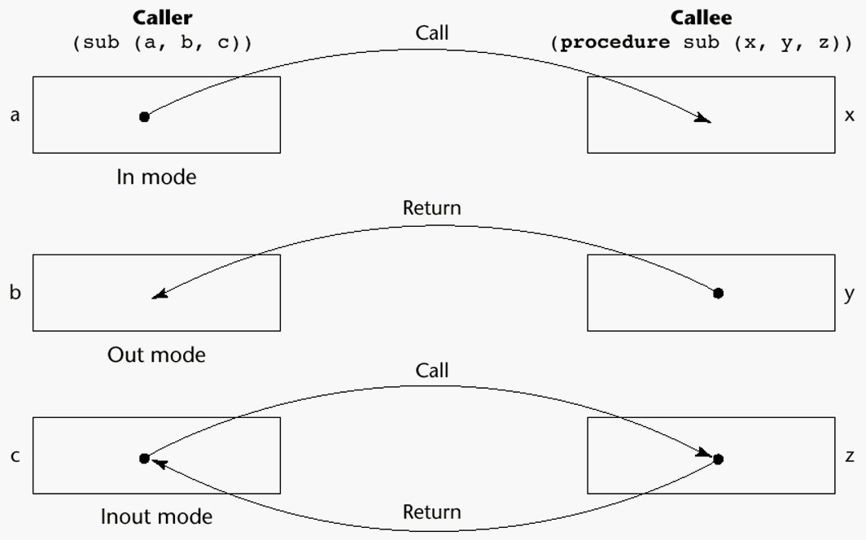-

Pass-by-value

Pass-by-result

Pass-by-value-result

Pass-by-reference

Pass-by-name

Models of Parameter Passing

Pass-by-Value (In Mode)

Principles of Programming Language

•The value of the actual parameter is used to initialize the corresponding formal parameter

-Normally implemented by copying

-Can be implemented by transmitting an access path but not recommended (enforcing write protection is not easy)

-When copies are used, additional storage is required

-Storage and copy operations can be costly Pass-by-Result (Out Mode)

•When a parameter is passed by result, no value is transmitted to the

subprogram; the corresponding formal parameter acts as a local variable; its

value is transmitted to caller‘s actual parameter when control is returned to the   
caller

-Require extra storage location and copy operation

•Potential problem: sub(p1, p1); whichever formal parameter is copied back will represent the current value of p1

Pass-by-Value-Result (inout Mode)

•

•

•

•

A combination of pass-by-value and pass-by-result

Sometimes called pass-by-copy

Formal parameters have local storage

Disadvantages:

-

-

Those of pass-by-result

Those of pass-by-value

Pass-by-Reference (Inout Mode)

•

Pass an access path

Principles of Programming Language

•

•

•

Also called pass-by-sharing

Passing process is efficient (no copying and no duplicated storage)

Disadvantages

-

-

-

Slower accesses (compared to pass-by-value) to formal parameters

Potentials for un-wanted side effects

Un-wanted aliases (access broadened)

Pass-by-Name (Inout Mode)

•By textual substitution

•Formals are bound to an access method at the time of the call, but actual   
binding to a value or address takes place at the time of a reference or   
assignment

•Allows flexibility in late binding

Implementing Parameter-Passing Methods

•In most language parameter communication takes place thru the run-time   
stack

•Pass-by-reference are the simplest to implement; only an address is placed in the stack

•A subtle but fatal error can occur with pass-by-reference and pass-by-value-  
result: a formal parameter corresponding to a constant can mistakenly be   
changed

Parameter Passing Methods of Major Languages

•Fortran

-Always used the inout semantics model

-Before Fortran 77: pass-by-reference

-Fortran 77 and later: scalar variables are often passed by value-result

•C

Principles of Programming Language

-Pass-by-value

-Pass-by-reference is achieved by using pointers as parameters

•C++

-A special pointer type called reference type for pass-by-reference

•Java

-All parameters are passed are passed by value

-Object parameters are passed by reference

•Ada

-Three semantics modes of parameter transmission: in, out, in out; in is the default mode

-Formal parameters declared out can be assigned but not referenced; those declared in can be referenced but not assigned; in out parameters can be referenced and assigned

•C#

-Default method: pass-by-value

-Pass-by-reference is specified by preceding both a formal parameter and its actual parameter with ref

•PHP: very similar to C#

•Perl: all actual parameters are implicitly placed in a predefined array named   
@_

Type Checking Parameters

•Considered very important for reliability

•FORTRAN 77 and original C: none

•Pascal, FORTRAN 90, Java, and Ada: it is always required

•ANSI C and C++: choice is made by the user

-Prototypes

•Relatively new languages Perl, JavaScript, and PHP do not require type checking

Principles of Programming Language

Multidimensional Arrays as Parameters

•If a multidimensional array is passed to a subprogram and the subprogram is separately compiled, the compiler needs to know the declared size of that array to build the storage mapping function

Multidimensional Arrays as Parameters: C and C++

•Programmer is required to include the declared sizes of all but the first subscript in the actual parameter

•Disallows writing flexible subprograms

•Solution: pass a pointer to the array and the sizes of the dimensions as other parameters; the user must include the storage mapping function in terms of the size parameters

Multidimensional Arrays as Parameters: Pascal and Ada

•Pascal

-Not a problem; declared size is part of the array‘s type

•Ada

-Constrained arrays - like Pascal

-Unconstrained arrays - declared size is part of the object declaration Multidimensional Arrays as Parameters: Fortran

•

Formal parameter that are arrays have a declaration after the header

-

-

For single-dimension arrays, the subscript is irrelevant

For multi-dimensional arrays, the subscripts allow the storage-mapping

function

Multidimensional Arrays as Parameters: Java and C#

•Similar to Ada

•Arrays are objects; they are all single-dimensioned, but the elements can be   
arrays

•Each array inherits a named constant (length in Java, Length in C#) that is

Principles of Programming Language

set to the length of the array when the array object is created Design Considerations for Parameter Passing

•Two important considerations

-Efficiency

-One-way or two-way data transfer

•But the above considerations are in conflict

-Good programming suggest limited access to variables, which means one-  
way whenever possible

-But pass-by-reference is more efficient to pass structures of significant size Parameters that are Subprogram Names

•It is sometimes convenient to pass subprogram names as parameters

•Issues:

•Are parameter types checked?

•What is the correct referencing environment for a subprogram that was sent as a parameter?

Parameters that are Subprogram Names: Parameter Type Checking

•C and C++: functions cannot be passed as parameters but pointers to functions can be passed; parameters can be type checked

•FORTRAN 95 type checks

•Later versions of Pascal and

•Ada does not allow subprogram parameters; a similar alternative is provided via Ada‘s generic facility

Parameters that are Subprogram Names: Referencing Environment

•Shallow binding: The environment of the call statement that enacts the passed subprogram

•Deep binding: The environment of the definition of the passed subprogram

•Ad hoc binding: The environment of the call statement that passed the subprogram

Overloaded Subprograms

Principles of Programming Language

•An overloaded subprogram is one that has the same name as another subprogram in the same referencing environment

-Every version of an overloaded subprogram has a unique protocol

•C++, Java, C#, and Ada include predefined overloaded subprograms

•In Ada, the return type of an overloaded function can be used to

disambiguate calls (thus two overloaded functions can have the same parameters)

•Ada, Java, C++, and C# allow users to write multiple versions of subprograms with the same name

Generic Subprograms

•A generic or polymorphic subprogram takes parameters of different types on different activations

•Overloaded subprograms provide ad hoc polymorphism

•A subprogram that takes a generic parameter that is used in a type

expression that describes the type of the parameters of the subprogram provides parametric polymorphism

Examples of parametric polymorphism: C++

template <class Type>

Type max(Type first, Type second) {

return first > second ? first : second;   
}

•The above template can be instantiated for any type for which operator > is   
defined

int max (int first, int second) {

return first > second? first : second;   
}

Design Issues for Functions

•Are side effects allowed?

-Parameters should always be in-mode to reduce side effect (like Ada)

•What types of return values are allowed?

-Most imperative languages restrict the return types

Principles of Programming Language

-C allows any type except arrays and functions

-C++ is like C but also allows user-defined types

-Ada allows any type

-Java and C# do not have functions but methods can have any type User-Defined Overloaded Operators

•Operators can be overloaded in Ada and C++

•An Ada example

Function ―*‖(A,B: in Vec_Type): return Integer is   
 Sum: Integer := 0;

begin

for Index in A‘range loop

Sum := Sum + A(Index) * B(Index)   
end loop

return sum;   
end ―*‖;

…

c = a * b; -- a, b, and c are of type Vec_Type

Coroutines

•A coroutine is a subprogram that has multiple entries and controls them   
itself

•Also called symmetric control: caller and called coroutines are on a more equal basis

•A coroutine call is named a resume

•The first resume of a coroutine is to its beginning, but subsequent calls enter at the point just after the last executed statement in the coroutine

•Coroutines repeatedly resume each other, possibly forever

•Coroutines provide quasi-concurrent execution of program units (the coroutines); their execution is interleaved, but not overlapped

Coroutines Illustrated: Possible Execution Controls

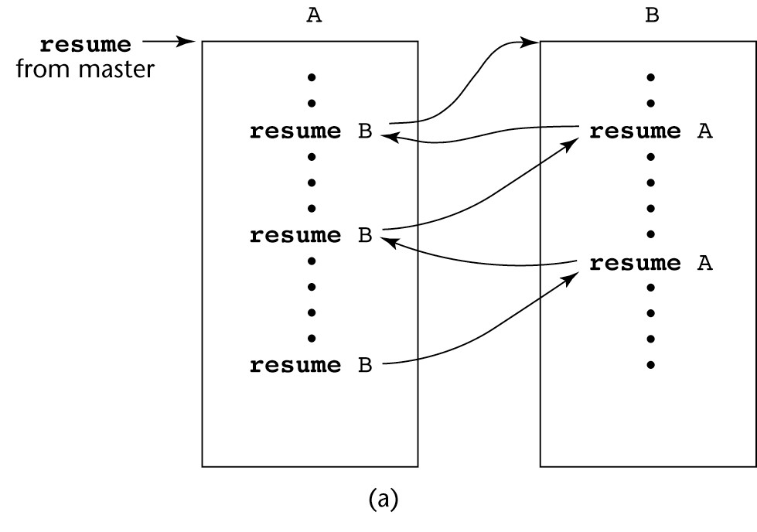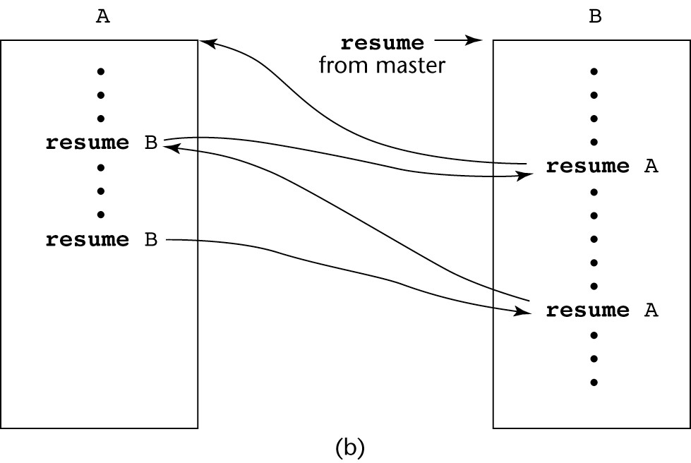

Principles of Programming Language

Coroutines Illustrated: Possible Execution Controls

Coroutines Illustrated: Possible Execution Controls with Loops

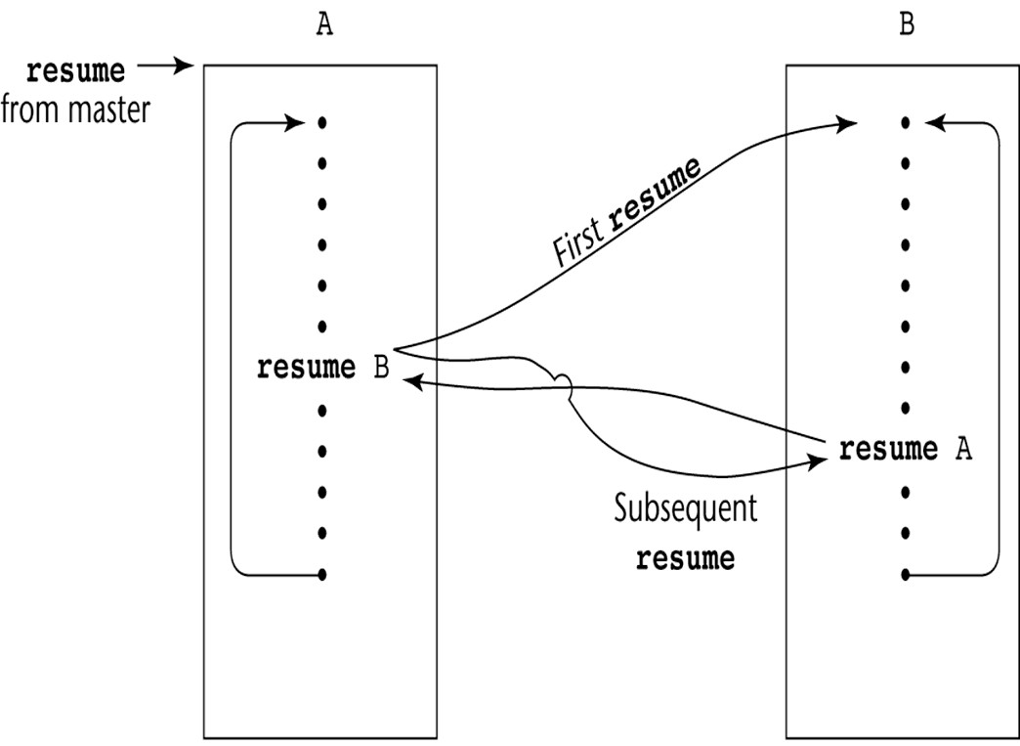

Principles of Programming Language

Summary

•A subprogram definition describes the actions represented by the subprogram

•Subprograms can be either functions or procedures

•Local variables in subprograms can be stack-dynamic or static

•Three models of parameter passing: in mode, out mode, and inout mode

•Some languages allow operator overloading

•Subprograms can be generic

•A coroutine is a special subprogram with multiple entries

Principles of Programming Language

UNIT-IV

Abstract Data types

Topics

• The Concept of Abstraction

• Introduction to Data Abstraction

• Design Issues for Abstract Data Types

• Language Examples

• Parameterized Abstract Data Types

• Encapsulation Constructs

• Naming Encapsulations

• Object-Oriented Programming

• Design Issues for Object-Oriented Languages

• Support for Object-Oriented Programming in Smalltalk

• Support for Object-Oriented Programming in C++

• Support for Object-Oriented Programming in Java

• Support for Object-Oriented Programming in C#

• Support for Object-Oriented Programming in Ada 95

• Implementation of Object-Oriented Constructs

• Concurrency Introduction

• Introduction to Subprogram-Level Concurrency

• Semaphores

• Monitors

• Message Passing

Principles of Programming Language

• Ada Support for Concurrency

• Java Threads

• C# Threads

• Statement-Level Concurrency

The Concept of Abstraction

•An abstraction is a view or representation of an entity that includes only the most significant attributes

•The concept of abstraction is fundamental in programming (and computer   
science)

•Nearly all programming languages support process abstraction with subprograms

•Nearly all programming languages designed since 1980 support data abstraction

Introduction to Data Abstraction

•An abstract data type is a user-defined data type that satisfies the following two conditions:

-The representation of, and operations on, objects of the type are defined in a single syntactic unit

-The representation of objects of the type is hidden from the program units

that use these objects, so the only operations possible are those provided in the type's definition

Advantages of Data Abstraction

•Advantage of the first condition

-Program organization, modifiability (everything associated with a data structure is together), and separate compilation

•Advantage the second condition

-Reliability--by hiding the data representations, user code cannot directly

Principles of Programming Language

access objects of the type or depend on the representation, allowing the representation to be changed without affecting user code   
Language Requirements for ADTs

•A syntactic unit in which to encapsulate the type definition

•A method of making type names and subprogram headers visible to clients, while hiding actual definitions

•Some primitive operations must be built into the language processor Design Issues

•Can abstract types be parameterized?

•What access controls are provided?

Language Examples: Ada

•The encapsulation construct is called a package

-Specification package (the interface)

-Body package (implementation of the entities named in the specification)

•Information Hiding

-The spec package has two parts, public and private

-The name of the abstract type appears in the public part of the specification package. This part may also include representations of unhidden types

-The representation of the abstract type appears in a part of the specification called the private part

•More restricted form with limited private types

Private types have built-in operations for assignment and comparison Limited private types have NO built-in operations

•Reasons for the public/private spec package:

1. The compiler must be able to see the representation after seeing only the spec package (it cannot see the private part)

2. Clients must see the type name, but not the representation (they also cannot see the private part)

•Having part of the implementation details (the representation) in the spec package and part (the method bodies) in the body package is not good

One solution: make all ADTs pointers

Principles of Programming Language

Problems with this:

1. Difficulties with pointers

2. Object comparisons

3. Control of object allocation is lost

An Example in Ada

package Stack_Pack is

type stack_type is limited private; max_size: constant := 100;

function empty(stk: in stack_type) return Boolean;

procedure push(stk: in out stack_type; elem:in Integer); procedure pop(stk: in out stack_type);

function top(stk: in stack_type) return Integer;

private -- hidden from clients

type list_type is array (1..max_size) of Integer; type stack_type is record

list: list_type;

topsub: Integer range 0..max_size) := 0; end record;

end Stack_Pack

Language Examples: C++

•Based on C struct type and Simula 67 classes

•The class is the encapsulation device

•All of the class instances of a class share a single copy of the member functions

•Each instance of a class has its own copy of the class data members

•Instances can be static, stack dynamic, or heap dynamic Language Examples: C++ (continued)

•Information Hiding

-Private clause for hidden entities

-Public clause for interface entities

-Protected clause for inheritance (Chapter 12) Language Examples: C++ (continued)

•Constructors:

Principles of Programming Language

-Functions to initialize the data members of instances (they do not create the   
objects)

-May also allocate storage if part of the object is heap-dynamic

-Can include parameters to provide parameterization of the objects

-Implicitly called when an instance is created

-Can be explicitly called

-Name is the same as the class name   
Language Examples: C++ (continued)

•Destructors

-Functions to cleanup after an instance is destroyed; usually just to reclaim heap storage

-Implicitly called when the object‘s lifetime ends

-Can be explicitly called

-Name is the class name, preceded by a tilde (~) An Example in C++

class stack {

private:

int *stackPtr, maxLen, topPtr;   
public:

stack() { // a constructor

stackPtr = new int [100]; maxLen = 99;

topPtr = -1;   
};

~stack () {delete [] stackPtr;}; void push (int num) {…}; void pop () {…};

int top () {…};

int empty () {…};   
}

Evaluation of ADTs in C++ and Ada

•C++ support for ADTs is similar to expressive power of Ada

Principles of Programming Language

•Both provide effective mechanisms for encapsulation and information hiding

•Ada packages are more general encapsulations; classes are types Language Examples: C++ (continued)

•Friend functions or classes - to provide access to private members to some unrelated units or functions

-Necessary in C++

Language Examples: Java

•Similar to C++, except:

-All user-defined types are classes

-All objects are allocated from the heap and accessed through reference variables

-Individual entities in classes have access control modifiers (private or public), rather than clauses

-Java has a second scoping mechanism, package scope, which can be used in place of friends

•All entities in all classes in a package that do not have access control modifiers are visible throughout the package

An Example in Java

class StackClass {   
 private:

private int [] *stackRef;

private int [] maxLen, topIndex;

public StackClass() { // a constructor   
 stackRef = new int [100];

maxLen = 99;

topPtr = -1;   
};

public void push (int num) {…}; public void pop () {…};

public int top () {…};

public boolean empty () {…};   
}

Language Examples: C#

•Based on C++ and Java

Principles of Programming Language

•Adds two access modifiers, internal and protected internal

•All class instances are heap dynamic

•Default constructors are available for all classes

•Garbage collection is used for most heap objects, so destructors are rarely   
used

•structs are lightweight classes that do not support inheritance

Language Examples: C# (continued)

•Common solution to need for access to data members: accessor methods (getter and setter)

•C# provides properties as a way of implementing getters and setters without requiring explicit method calls

C# Property Example

public class Weather {

public int DegreeDays { //** DegreeDays is a property   
 get {return degreeDays;}

set {

if(value < 0 || value > 30) Console.WriteLine(

"Value is out of range: {0}", value); else degreeDays = value;}

}

private int degreeDays;

}

Weather w = new Weather();

int degreeDaysToday, oldDegreeDays;

w.DegreeDays = degreeDaysToday;   
oldDegreeDays = w.DegreeDays;

Parameterized Abstract Data Types

•Parameterized ADTs allow designing an ADT that can store any type elements (among other things)

•Also known as generic classes

Principles of Programming Language

•C++, Ada, Java 5.0, and C# 2005 provide support for parameterized ADTs Parameterized ADTs in Ada

•Ada Generic Packages

-Make the stack type more flexible by making the element type and the size of the stack generic

generic

Max_Size: Positive;

type Elem_Type is private;   
package Generic_Stack is

Type Stack_Type is limited private;

function Top(Stk: in out StackType) return Elem_type;   
…

end Generic_Stack;

Package Integer_Stack is new Generic_Stack(100,Integer);   
Package Float_Stack is new Generic_Stack(100,Float);

Parameterized ADTs in C++

•

Classes can be somewhat generic by writing parameterized constructor

functions

class stack {   
…

stack (int size) {

stk_ptr = new int [size];   
max_len = size - 1;   
top = -1;

};

…   
}

stack stk(100);

Parameterized ADTs in C++ (continued)

•The stack element type can be parameterized by making the class a templated class

template <class Type> class stack {

private:

Principles of Programming Language

Type *stackPtr;

const int maxLen; int topPtr;

public:

stack() {

stackPtr = new Type[100]; maxLen = 99;

topPtr = -1;   
}

…   
}

Parameterized Classes in Java 5.0

•Generic parameters must be classes

•Most common generic types are the collection types, such as LinkedList and ArrayList

•Eliminate the need to cast objects that are removed

•Eliminate the problem of having multiple types in a structure Parameterized Classes in C# 2005

•Similar to those of Java 5.0

•Elements of parameterized structures can be accessed through indexing Summary

•The concept of ADTs and their use in program design was a milestone in the development of languages

•Two primary features of ADTs are the packaging of data with their associated operations and information hiding

•Ada provides packages that simulate ADTs

•C++ data abstraction is provided by classes

•Java‘s data abstraction is similar to C++

•Ada, C++, Java 5.0, and C# 2005 support parameterized ADTs Object-Oriented Programming

•Abstract data types

•Inheritance

Principles of Programming Language

-Inheritance is the central theme in OOP and languages that support it

•Polymorphism

Inheritance

•Productivity increases can come from reuse

-ADTs are difficult to reuse—always need changes

-All ADTs are independent and at the same level

•Inheritance allows new classes defined in terms of existing ones, i.e., by allowing them to inherit common parts

•Inheritance addresses both of the above concerns--reuse ADTs after minor changes and define classes in a hierarchy

Object-Oriented Concepts

•ADTs are usually called classes

•Class instances are called objects

•A class that inherits is a derived class or a subclass

•The class from which another class inherits is a parent class or superclass

•Subprograms that define operations on objects are called methods Object-Oriented Concepts (continued)

•Calls to methods are called messages

•The entire collection of methods of an object is called its message protocol or message interface

•Messages have two parts--a method name and the destination object

•In the simplest case, a class inherits all of the entities of its parent Object-Oriented Concepts (continued)

•Inheritance can be complicated by access controls to encapsulated entities

-A class can hide entities from its subclasses

-A class can hide entities from its clients

-A class can also hide entities for its clients while allowing its subclasses to see them

•Besides inheriting methods as is, a class can modify an inherited method

Principles of Programming Language

-The new one overrides the inherited one

-The method in the parent is overriden   
Object-Oriented Concepts (continued)

•There are two kinds of variables in a class:

-Class variables - one/class

-Instance variables - one/object

•There are two kinds of methods in a class:

-Class methods - accept messages to the class

-Instance methods - accept messages to objects

•Single vs. Multiple Inheritance

•One disadvantage of inheritance for reuse:

-Creates interdependencies among classes that complicate maintenance Dynamic Binding

•A polymorphic variable can be defined in a class that is able to reference (or point to) objects of the class and objects of any of its descendants

•When a class hierarchy includes classes that override methods and such

methods are called through a polymorphic variable, the binding to the correct method will be dynamic

•Allows software systems to be more easily extended during both development and maintenance

Dynamic Binding Concepts

•An abstract method is one that does not include a definition (it only defines a protocol)

•An abstract class is one that includes at least one virtual method

•An abstract class cannot be instantiated

Design Issues for OOP Languages

•The Exclusivity of Objects

•Are Subclasses Subtypes

•Type Checking and Polymorphism

•Single and Multiple Inheritance

Principles of Programming Language

•Object Allocation and DeAllocation

•Dynamic and Static Binding

•Nested Classes

The Exclusivity of Objects

•Everything is an object

-Advantage - elegance and purity

-Disadvantage - slow operations on simple objects

•Add objects to a complete typing system

-Advantage - fast operations on simple objects

-Disadvantage - results in a confusing type system (two kinds of entities)

•Include an imperative-style typing system for primitives but make everything else objects

-Advantage - fast operations on simple objects and a relatively small typing   
system

-Disadvantage - still some confusion because of the two type systems Are Subclasses Subtypes?

•Does an ―is-a‖ relationship hold between a parent class object and an object of the subclass?

-If a derived class is-a parent class, then objects of the derived class must behave the same as the parent class object

•A derived class is a subtype if it has an is-a relationship with its parent class

-Subclass can only add variables and methods and override inherited methods in ―compatible‖ ways

Type Checking and Polymorphism

•Polymorphism may require dynamic type checking of parameters and the return value

-Dynamic type checking is costly and delays error detection

•If overriding methods are restricted to having the same parameter types and

Principles of Programming Language

return type, the checking can be static Single and Multiple Inheritance

•Multiple inheritance allows a new class to inherit from two or more classes

•Disadvantages of multiple inheritance:

-Language and implementation complexity (in part due to name collisions)

-Potential inefficiency - dynamic binding costs more with multiple inheritance (but not much)

•Advantage:

-Sometimes it is quite convenient and valuable Allocation and DeAllocation of Objects

•From where are objects allocated?

-If they behave line the ADTs, they can be allocated from anywhere

•Allocated from the run-time stack

•Explicitly create on the heap (via new)

-If they are all heap-dynamic, references can be uniform thru a pointer or reference variable

•Simplifies assignment - dereferencing can be implicit

-If objects are stack dynamic, there is a problem with regard to subtypes

•Is deallocation explicit or implicit?

Dynamic and Static Binding

•Should all binding of messages to methods be dynamic?

-If none are, you lose the advantages of dynamic binding

-If all are, it is inefficient

•Allow the user to specify Nested Classes

•If a new class is needed by only one class, there is no reason to define so it can be seen by other classes

-Can the new class be nested inside the class that uses it?

Principles of Programming Language

-In some cases, the new class is nested inside a subprogram rather than directly in another class

•Other issues:

-Which facilities of the nesting class should be visible to the nested class and vice versa

Support for OOP in Smalltalk

•Smalltalk is a pure OOP language

-Everything is an object

-All objects have local memory

-All computation is through objects sending messages to objects

-None of the appearances of imperative languages

-All objected are allocated from the heap

-All deallocation is implicit

Support for OOP in Smalltalk (continued)

•Type Checking and Polymorphism

-All binding of messages to methods is dynamic

•The process is to search the object to which the message is sent for the

method; if not found, search the superclass, etc. up to the system class which has no superclass

-The only type checking in Smalltalk is dynamic and the only type error   
occurs when a message is sent to an object that has no matching method

Support for OOP in Smalltalk (continued)

•Inheritance

-A Smalltalk subclass inherits all of the instance variables, instance methods, and class methods of its superclass

-All subclasses are subtypes (nothing can be hidden)

-All inheritance is implementation inheritance

Principles of Programming Language

-No multiple inheritance

Support for OOP in Smalltalk (continued)

•Evaluation of Smalltalk

-The syntax of the language is simple and regular

-Good example of power provided by a small language

-Slow compared with conventional compiled imperative languages

-Dynamic binding allows type errors to go undetected until run time

-Introduced the graphical user interface

-Greatest impact: advancement of OOP Support for OOP in C++

•General Characteristics:

-Evolved from C and SIMULA 67

-Among the most widely used OOP languages

-Mixed typing system

-Constructors and destructors

-Elaborate access controls to class entities Support for OOP in C++ (continued)

•Inheritance

-A class need not be the subclass of any class

-Access controls for members are

-Private (visible only in the class and friends) (disallows subclasses from being subtypes)

-Public (visible in subclasses and clients)

-Protected (visible in the class and in subclasses, but not clients) Support for OOP in C++ (continued)

•In addition, the subclassing process can be declared with access controls

Principles of Programming Language

(private or public), which define potential changes in access by subclasses

-Private derivation - inherited public and protected members are private in the subclasses

-Public derivation public and protected members are also public and protected in subclasses

Inheritance Example in C++ class base_class {

private:

int a;

float x;

protected:   
int b;

float y;   
public:   
int c;

float z;   
};

class subclass_1 : public base_class { … }; // In this one, b and y are protected and // c and z are public

class subclass_2 : private base_class { … }; // In this one, b, y, c, and z are private, // and no derived class has access to any // member of base_class

Reexportation in C++

•A member that is not accessible in a subclass (because of private derivation)   
can be declared to be visible there using the scope resolution operator (::), e.g.,

class subclass_3 : private base_class {

base_class :: c;

…

}

Reexportation (continued)

•One motivation for using private derivation

-A class provides members that must be visible, so they are defined to be

public members; a derived class adds some new members, but does not want its clients to see the members of the parent class, even though they had to be public in the parent class definition

Support for OOP in C++ (continued)

Principles of Programming Language

•Multiple inheritance is supported

-If there are two inherited members with the same name, they can both be referenced using the scope resolution operator

Support for OOP in C++ (continued)

•Dynamic Binding

-A method can be defined to be virtual, which means that they can be called through polymorphic variables and dynamically bound to messages

-A pure virtual function has no definition at all

-A class that has at least one pure virtual function is an abstract class Support for OOP in C++ (continued)

•Evaluation

-C++ provides extensive access controls (unlike Smalltalk)

-C++ provides multiple inheritance

-In C++, the programmer must decide at design time which methods will be statically bound and which must be dynamically bound

•Static binding is faster!

-Smalltalk type checking is dynamic (flexible, but somewhat unsafe)

-Because of interpretation and dynamic binding, Smalltalk is ~10 times slower than C++

Support for OOP in Java

•Because of its close relationship to C++, focus is on the differences from that language

•General Characteristics

-All data are objects except the primitive types

-All primitive types have wrapper classes that store one data value

-All objects are heap-dynamic, are referenced through reference variables, and most are allocated with new

-A finalize method is implicitly called when the garbage collector is about to reclaim the storage occupied by the object

Principles of Programming Language

Support for OOP in Java (continued)

•Inheritance

-Single inheritance supported only, but there is an abstract class category that provides some of the benefits of multiple inheritance (interface)

-An interface can include only method declarations and named constants,   
e.g.,

public interface Comparable {

public int comparedTo (Object b);   
}

-Methods can be final (cannot be overriden) Support for OOP in Java (continued)

•Dynamic Binding

-In Java, all messages are dynamically bound to methods, unless the method   
is final (i.e., it cannot be overriden, therefore dynamic binding serves no   
purpose)

-Static binding is also used if the methods is static or private both of which disallow overriding

Support for OOP in Java (continued)

•Several varieties of nested classes

•All are hidden from all classes in their package, except for the nesting class

•Nested classes can be anonymous

•A local nested class is defined in a method of its nesting class

-No access specifier is used

Support for OOP in Java (continued)

•Evaluation

-Design decisions to support OOP are similar to C++

-No support for procedural programming

-No parentless classes

-Dynamic binding is used as ―normal‖ way to bind method calls to method definitions

Principles of Programming Language

-Uses interfaces to provide a simple form of support for multiple inheritance Support for OOP in C#

•General characteristics

-Support for OOP similar to Java

-Includes both classes and structs

-Classes are similar to Java‘s classes

-structs are less powerful stack-dynamic constructs (e.g., no inheritance) Support for OOP in C# (continued)

•Inheritance

-Uses the syntax of C++ for defining classes

-A method inherited from parent class can be replaced in the derived class by marking its definition with new

-The parent class version can still be called explicitly with the prefix base: base.Draw()

Support for OOP in C#

•Dynamic binding

-To allow dynamic binding of method calls to methods:

•The base class method is marked virtual

•The corresponding methods in derived classes are marked override

-Abstract methods are marked abstract and must be implemented in all subclasses

-All C# classes are ultimately derived from a single root class, Object Support for OOP in C# (continued)

•Nested Classes

-A C# class that is directly nested in a nesting class behaves like a Java static nested class

-C# does not support nested classes that behave like the non-static classes of

Principles of Programming Language

Java

Support for OOP in C#

•Evaluation

-C# is the most recently designed C-based OO language

-The differences between C#‘s and Java‘s support for OOP are relatively minor Support for OOP in Ada 95

•General Characteristics

-OOP was one of the most important extensions to Ada 83

-Encapsulation container is a package that defines a tagged type

-A tagged type is one in which every object includes a tag to indicate during execution its type (the tags are internal)

-Tagged types can be either private types or records

-No constructors or destructors are implicitly called Support for OOP in Ada 95 (continued)

•Inheritance

-Subclasses can be derived from tagged types

-New entities are added to the inherited entities by placing them in a record definition

-All subclasses are subtypes

-No support for multiple inheritance

•A comparable effect can be achieved using generic classes Example of a Tagged Type

Package Person_Pkg is

type Person is tagged private;

procedure Display(P : in out Person);   
private

type Person is tagged   
record

Name : String(1..30);

Address : String(1..30); Age : Integer;

end record;

Principles of Programming Language

end Person_Pkg;

with Person_Pkg; use Person_Pkg; package Student_Pkg is

type Student is new Person with   
record

Grade_Point_Average : Float;   
Grade_Level : Integer;   
end record;

procedure Display (St: in Student); end Student_Pkg;

// Note: Display is being overridden from Person_Pkg Support for OOP in Ada 95 (continued)

•Dynamic Binding

-Dynamic binding is done using polymorphic variables called classwide types

•For the tagged type Prtdon, the classwide type is Person‘ class

-Other bindings are static

-Any method may be dynamically bound

-Purely abstract base types can be defined in Ada 95 by including the reserved word abstract

Support for OOP in Ada 95 (continued)

•Evaluation

-Ada offers complete support for OOP

-C++ offers better form of inheritance than Ada

-Ada includes no initialization of objects (e.g., constructors)

-Dynamic binding in C-based OOP languages is restricted to pointers and/or references to objects; Ada has no such restriction and is thus more orthogonal Implementing OO Constructs

•Two interesting and challenging parts

-Storage structures for instance variables

-Dynamic binding of messages to methods Instance Data Storage

Principles of Programming Language

•Class instance records (CIRs) store the state of an object

-Static (built at compile time)

•If a class has a parent, the subclass instance variables are added to the parent CIR

•Because CIR is static, access to all instance variables is done as it is in   
records

-Efficient

Dynamic Binding of Methods Calls

•Methods in a class that are statically bound need not be involved in the CIR; methods that will be dynamically bound must have entries in the CIR

-Calls to dynamically bound methods can be connected to the corresponding code thru a pointer in the CIR

-The storage structure is sometimes called virtual method tables (vtable)

-Method calls can be represented as offsets from the beginning of the vtable Summary

•OO programming involves three fundamental concepts: ADTs, inheritance, dynamic binding

•Major design issues: exclusivity of objects, subclasses and subtypes, type

checking and polymorphism, single and multiple inheritance, dynamic binding, explicit and implicit de-allocation of objects, and nested classes

•Smalltalk is a pure OOL

•C++ has two distinct type system (hybrid)

•Java is not a hybrid language like C++; it supports only OO programming

•C# is based on C++ and Java

•Implementing OOP involves some new data structures

Concurrency Introduction

• Concurrency can occur at four levels:

- Machine instruction level

Principles of Programming Language

- High-level language statement level

- Unit level

- Program level

• Because there are no language issues in instruction- and program-level   
 concurrency, they are not addressed here

Multiprocessor Architectures

• Late 1950s - one general-purpose processor and one or more special-  
 purpose processors for input and output operations

• Early 1960s - multiple complete processors, used for program-level   
 concurrency

• Mid-1960s - multiple partial processors, used for instruction-level   
 concurrency

• Single-Instruction Multiple-Data (SIMD) machines

• Multiple-Instruction Multiple-Data (MIMD) machines

- Independent processors that can be synchronized (unit-level   
 concurrency)

Categories of Concurrency

• A thread of control in a program is the sequence of program points reached   
 as control flows through the program

• Categories of Concurrency:

- Physical concurrency - Multiple independent processors ( multiple   
 threads of control)

- Logical concurrency - The appearance of physical concurrency is

presented by time-sharing one processor (software can be designed as if there were multiple threads of control)

• Coroutines (quasi-concurrency) have a single thread of control Motivations for Studying Concurrency

• Involves a different way of designing software that can be very useful—   
 many real-world situations involve concurrency

Principles of Programming Language

• Multiprocessor computers capable of physical concurrency are now widely   
 used

Introduction to Subprogram-Level Concurrency

• A task or process is a program unit that can be in concurrent execution   
 with other program units

• Tasks differ from ordinary subprograms in that:

- A task may be implicitly started

- When a program unit starts the execution of a task, it is not   
 necessarily suspended

- When a task‘s execution is completed, control may not return to the   
 caller

• Tasks usually work together   
Two General Categories of Tasks

• Heavyweight tasks execute in their own address space

• Lightweight tasks all run in the same address space

• A task is disjoint if it does not communicate with or affect the execution of   
 any other task in the program in any way

Task Synchronization

• A mechanism that controls the order in which tasks execute

• Two kinds of synchronization

- Cooperation synchronization

- Competition synchronization

• Task communication is necessary for synchronization, provided by:

- Shared nonlocal variables

- Parameters

- Message passing

Kinds of synchronization

• Cooperation: Task A must wait for task B to complete some specific activity   
 before task A can continue its execution, e.g., the producer-consumer   
 problem

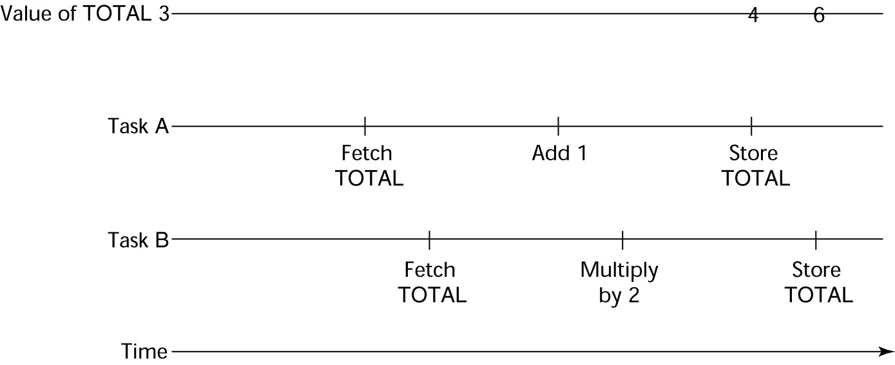

Principles of Programming Language

• Competition: Two or more tasks must use some resource that cannot be   
 simultaneously used, e.g., a shared counter

- Competition is usually provided by mutually exclusive access   
 (approaches are discussed later)

Need for Competition Synchronization

Scheduler

• Providing synchronization requires a mechanism for delaying task   
 execution

• Task execution control is maintained by a program called the scheduler,   
 which maps task execution onto available processors

Task Execution States

• New - created but not yet started

• Ready - ready to run but not currently running (no available processor)

• Running

• Blocked - has been running, but cannot now continue (usually waiting for   
 some event to occur)

• Dead - no longer active in any sense Liveness and Deadlock

• Liveness is a characteristic that a program unit may or may not have

- In sequential code, it means the unit will

eventually complete its execution

Principles of Programming Language

• In a concurrent environment, a task can easily lose its liveness

• If all tasks in a concurrent environment lose their liveness, it is called   
 deadlock

Design Issues for Concurrency

• Competition and cooperation synchronization

• Controlling task scheduling

• How and when tasks start and end execution

• How and when are tasks created

Methods of Providing Synchronization

• Semaphores

• Monitors

• Message Passing Semaphores

• Dijkstra - 1965

• A semaphore is a data structure consisting of a counter and a queue for   
 storing task descriptors

• Semaphores can be used to implement guards on the code that accesses   
 shared data structures

• Semaphores have only two operations, wait and release (originally called P   
 and V by Dijkstra)

• Semaphores can be used to provide both competition and cooperation   
 synchronization

Cooperation Synchronization with Semaphores

• Example: A shared buffer

• The buffer is implemented as an ADT with the operations DEPOSIT and   
 FETCH as the only ways to access the buffer

• Use two semaphores for cooperation: emptyspots and fullspots

• The semaphore counters are used to store the numbers of empty spots   
 and full spots in the buffer

Principles of Programming Language

• DEPOSIT must first check emptyspots to see if there is room in the buffer

• If there is room, the counter of emptyspots is decremented and the value is   
 inserted

• If there is no room, the caller is stored in the queue of emptyspots

• When DEPOSIT is finished, it must increment the counter of fullspots

• FETCH must first check fullspots to see if there is a value

- If there is a full spot, the counter of fullspots is decremented and the   
 value is removed

- If there are no values in the buffer, the caller must be placed in the   
 queue of fullspots

- When FETCH is finished, it increments the counter of emptyspots

• The operations of FETCH and DEPOSIT on the semaphores are

accomplished through two semaphore operations named wait and release

Semaphores: Wait Operation

wait(aSemaphore)

if aSemaphore‘s counter > 0 then

decrement aSemaphore‘s counter   
else

put the caller in aSemaphore‘s queue

attempt to transfer control to a ready task

-- if the task ready queue is empty,

-- deadlock occurs

end

Semaphores: Release Operation

release(aSemaphore)

if aSemaphore‘s queue is empty then   
increment aSemaphore‘s counter   
else

put the calling task in the task ready queue

transfer control to a task from aSemaphore‘s queue   
end

Producer Consumer Code

semaphore fullspots, emptyspots; fullstops.count = 0;

emptyspots.count = BUFLEN; task producer;

loop

Principles of Programming Language

-- produce VALUE --

wait (emptyspots); {wait for space} DEPOSIT(VALUE);

release(fullspots); {increase filled} end loop;

end producer;

Producer Consumer Code

task consumer;

loop

wait (fullspots);{wait till not empty}} FETCH(VALUE);

release(emptyspots); {increase empty}

-- consume VALUE --

end loop;

end consumer;

Competition Synchronization with Semaphores

• A third semaphore, named access, is used to control access (competition   
 synchronization)

- The counter of access will only have the values 0 and 1

- Such a semaphore is called a binary semaphore

• Note that wait and release must be atomic!

Producer Consumer Code

semaphore access, fullspots, emptyspots; access.count = 0;

fullstops.count = 0;

emptyspots.count = BUFLEN; task producer;

loop

-- produce VALUE --

wait(emptyspots); {wait for space}

wait(access); {wait for access)

DEPOSIT(VALUE);

release(access); {relinquish access}   
release(fullspots); {increase filled}   
end loop;

end producer;

Producer Consumer Code

task consumer;

Principles of Programming Language

loop

wait(fullspots);{wait till not empty} wait(access); {wait for access} FETCH(VALUE);

release(access); {relinquish access}

release(emptyspots); {increase empty}

-- consume VALUE --

end loop;

end consumer;

Evaluation of Semaphores

• Misuse of semaphores can cause failures in cooperation synchronization,   
 e.g., the buffer will overflow if the wait of fullspots is left out

• Misuse of semaphores can cause failures in competition synchronization,   
 e.g., the program will deadlock if the release of access is left out

Monitors

• Ada, Java, C#

• The idea: encapsulate the shared data and its operations to restrict access

• A monitor is an abstract data type for shared data

Competition Synchronization

• Shared data is resident in the monitor (rather than in the client units)

• All access resident in the monitor

- Monitor implementation guarantee synchronized access by allowing   
 only one access at a time

- Calls to monitor procedures are implicitly queued if the monitor is   
 busy at the time of the call

Cooperation Synchronization

• Cooperation between processes is still a programming task

- Programmer must guarantee that a shared buffer does not   
 experience underflow or overflow

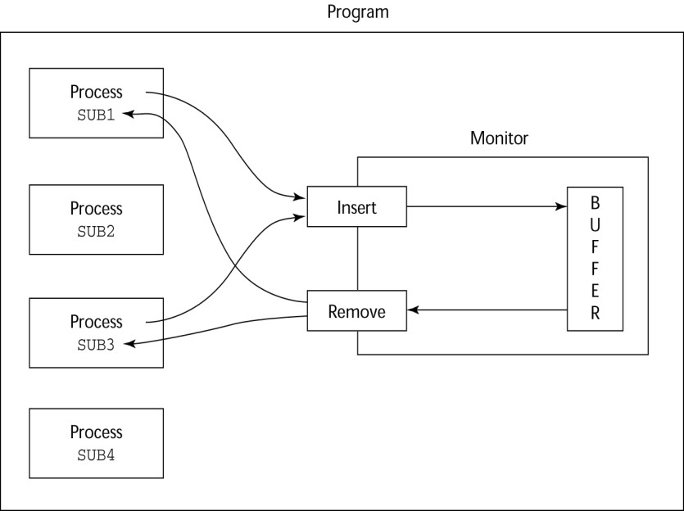

Principles of Programming Language

Evaluation of Monitors

• A better way to provide competition synchronization than are semaphores

• Semaphores can be used to implement monitors

• Monitors can be used to implement semaphores

• Support for cooperation synchronization is very similar as with   
 semaphores, so it has the same problems

Message Passing

• Message passing is a general model for concurrency

- It can model both semaphores and monitors

- It is not just for competition synchronization

• Central idea: task communication is like seeing a doctor--most of the time   
 she waits for you or you wait for her, but when you are both ready, you get   
 together, or rendezvous

Message Passing Rendezvous

• To support concurrent tasks with message passing, a language needs:

- A mechanism to allow a task to indicate when it is willing to accept messages

- A way to remember who is waiting to have its message accepted and

Principles of Programming Language

some ―fair‖ way of choosing the next message

• When a sender task‘s message is accepted by a receiver task, the actual   
 message transmission is called a rendezvous

Ada Support for Concurrency

• The Ada 83 Message-Passing Model

- Ada tasks have specification and body parts, like packages; the spec   
 has the interface, which is the collection of entry points:

task Task_Example is

entry ENTRY_1 (Item : in Integer); end Task_Example;

Task Body

• The body task describes the action that takes place when a rendezvous   
 occurs

• A task that sends a message is suspended while waiting for the message to   
 be accepted and during the rendezvous

• Entry points in the spec are described with accept clauses in the body   
 accept entry_name (formal parameters) do

…

end entry_name

Example of a Task Body

task body Task_Example is   
begin

loop

accept Entry_1 (Item: in Float) do

end Entry_1;

end loop;

end Task_Example;

Ada Message Passing Semantics

• The task executes to the top of the accept clause and waits for a message

• During execution of the accept clause, the sender is suspended

• accept parameters can transmit information in either or both directions

• Every accept clause has an associated queue to store waiting messages Rendezvous Time Lines

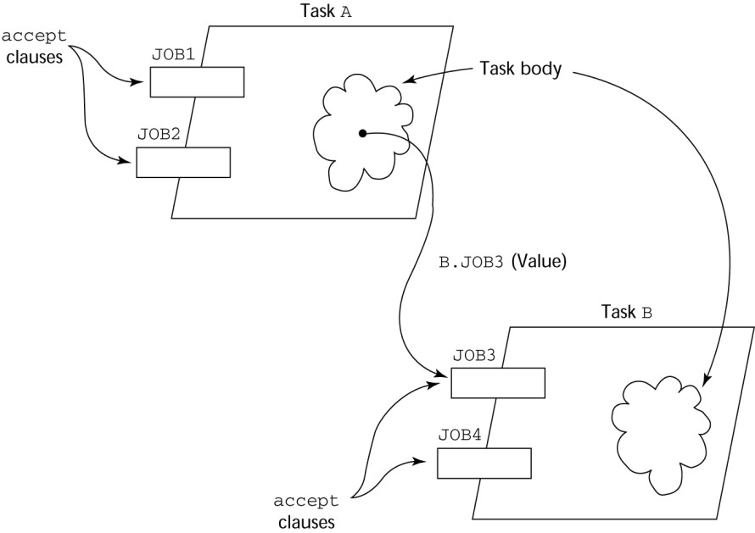

Principles of Programming Language

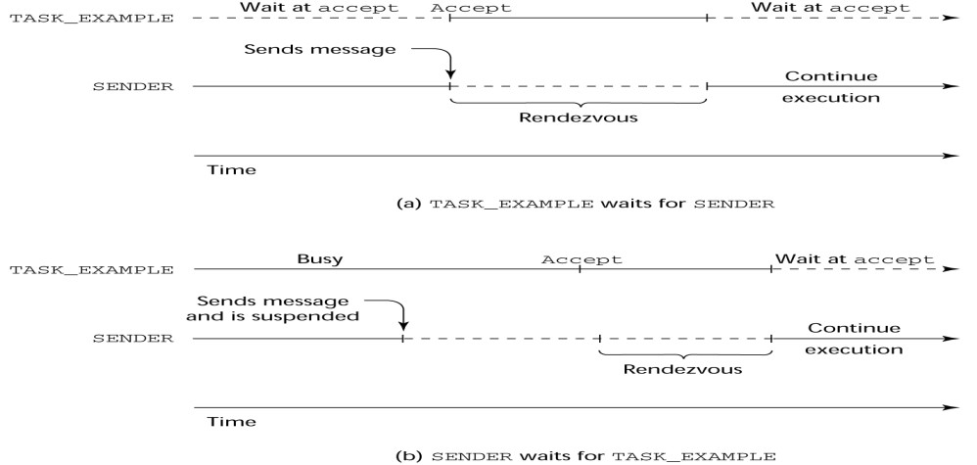

Message Passing: Server/Actor Tasks

• A task that has accept clauses, but no other code is called a server task   
 (the example above is a server task)

• A task without accept clauses is called an actor task

- An actor task can send messages to other tasks

- Note: A sender must know the entry name of the receiver, but not   
 vice versa (asymmetric)

Graphical Representation of a Rendezvous

Example: Actor Task

Principles of Programming Language

task Water_Monitor; -- specificationtask body body Water_Monitor is -- body   
 begin

loop

if Water_Level > Max_Level then Sound_Alarm;

end if;

delay 1.0; -- No further execution

-- for at least 1 second

end loop;

end Water_Monitor;

Multiple Entry Points

• Tasks can have more than one entry point

- The specification task has an entry clause for each

- The task body has an accept clause for each entry clause, placed in a   
 select clause, which is in a loop

A Task with Multiple Entries

task body Teller is

loop

select

accept Drive_Up(formal params) do

end Drive_Up;

or

accept Walk_Up(formal params) do

end Walk_Up;

end select;   
end loop;   
end Teller;

Semantics of Tasks with Multiple accept Clauses

• If exactly one entry queue is nonempty, choose a message from it

• If more than one entry queue is nonempty, choose one,   
 nondeterministically, from which to accept a message

• If all are empty, wait

Principles of Programming Language

• The construct is often called a selective wait

• Extended accept clause - code following the clause, but before the next   
 clause

- Executed concurrently with the caller

Cooperation Synchronization with Message Passing

• Provided by Guarded accept clauses   
 when not Full(Buffer) =>

accept Deposit (New_Value) do

• An accept clause with a with a when clause is either open or closed

- A clause whose guard is true is called open

- A clause whose guard is false is called closed

- A clause without a guard is always open

Semantics of select with Guarded accept Clauses:

• select first checks the guards on all clauses

• If exactly one is open, its queue is checked for messages

• If more than one are open, non-deterministically choose a queue among   
 them to check for messages

• If all are closed, it is a runtime error

• A select clause can include an else clause to avoid the error

- When the else clause completes, the loop repeats Example of a Task with Guarded accept Clauses

• Note: The station may be out of gas and there may or may not be a   
 position available in the garage

task Gas_Station_Attendant is

entry Service_Island (Car : Car_Type); entry Garage (Car : Car_Type);

Principles of Programming Language

end Gas_Station_Attendant;

Example of a Task with Guarded accept Clauses

task body Gas_Station_Attendant is

begin

loop

select

when Gas_Available =>

accept Service_Island (Car : Car_Type) do Fill_With_Gas (Car);

end Service_Island;   
or

when Garage_Available =>

accept Garage (Car : Car_Type) do Fix (Car);

end Garage;   
else

Sleep;

end select;   
end loop;

end Gas_Station_Attendant;

Competition Synchronization with Message Passing

• Modeling mutually exclusive access to shared data

• Example--a shared buffer

• Encapsulate the buffer and its operations in a task

• Competition synchronization is implicit in the semantics of accept clauses

- Only one accept clause in a task can be active at any given time Task Termination

• The execution of a task is completed if control has reached the end of its   
 code body

• If a task has created no dependent tasks and is completed, it is terminated

• If a task has created dependent tasks and is completed, it is not   
 terminated until all its dependent tasks are terminated

The terminate Clause

• A terminate clause in a select is just a terminate statement

• A terminate clause is selected when no accept clause is open

Principles of Programming Language

• When a terminate is selected in a task, the task is terminated only when   
 its master and all of the dependents of its master are either completed or   
 are waiting at a terminate

• A block or subprogram is not left until all of its dependent tasks are   
 terminated

Message Passing Priorities

• The priority of any task can be set with the pragma priority   
 pragma Priority (expression);

• The priority of a task applies to it only when it is in the task ready queue Binary Semaphores

• For situations where the data to which access is to be controlled is NOT   
 encapsulated in a task

task Binary_Semaphore is entry Wait;

entry release;

end Binary_Semaphore;

task body Binary_Semaphore is   
begin

loop

accept Wait;

accept Release; end loop;

end Binary_Semaphore;

Concurrency in Ada 95

• Ada 95 includes Ada 83 features for concurrency, plus two new features

- Protected objects: A more efficient way of implementing shared data   
 to allow access to a shared data structure to be done without   
 rendezvous

- Asynchronous communication

Ada 95: Protected Objects

• A protected object is similar to an abstract data type

• Access to a protected object is either through messages passed to entries,

Principles of Programming Language

as with a task, or through protected subprograms

• A protected procedure provides mutually exclusive read-write access to   
 protected objects

• A protected function provides concurrent read-only access to protected   
 objects

Asynchronous Communication

• Provided through asynchronous select structures

• An asynchronous select has two triggering alternatives, an entry clause or   
 a delay

- The entry clause is triggered when sent a message

- The delay clause is triggered when its time limit is reached Evaluation of the Ada

• Message passing model of concurrency is powerful and general

• Protected objects are a better way to provide synchronized shared data

• In the absence of distributed processors, the choice between monitors and   
 tasks with message passing is somewhat a matter of taste

• For distributed systems, message passing is a better model for   
 concurrency

Java Threads

• The concurrent units in Java are methods named run

- A run method code can be in concurrent execution with other such   
 methods

- The process in which the run methods execute is called a thread Class myThread extends Thread

public void run () {…}

}

…

Thread myTh = new MyThread (); myTh.start();

Controlling Thread Execution

• The Thread class has several methods to control the execution of threads

Principles of Programming Language

- The yield is a request from the running thread to voluntarily   
 surrender the processor

- The sleep method can be used by the caller of the method to block   
 the thread

- The join method is used to force a method to delay its execution until   
 the run method of another thread has completed its execution

Thread Priorities

• A thread‘s default priority is the same as the thread that create it

- If main creates a thread, its default priority is NORM_PRIORITY

• Threads defined two other priority constants, MAX_PRIORITY and   
 MIN_PRIORITY

• The priority of a thread can be changed with the methods setPriority Competition Synchronization with Java Threads

• A method that includes the synchronized modifier disallows any other   
 method from running on the object while it is in execution

…

public synchronized void deposit( int i) {…}   
public synchronized int fetch() {…}   
…

• The above two methods are synchronized which prevents them from   
 interfering with each other

• If only a part of a method must be run without interference, it can be   
 synchronized thru synchronized statement

synchronized (expression)

statement

Cooperation Synchronization with Java Threads

• Cooperation synchronization in Java is achieved via wait, notify, and   
 notifyAll methods

- All methods are defined in Object, which is the root class in Java, so   
 all objects inherit them

• The wait method must be called in a loop

Principles of Programming Language

• The notify method is called to tell one waiting thread that the event it was   
 waiting has happened

• The notifyAll method awakens all of the threads on the object‘s wait list Java’s Thread Evaluation

• Java‘s support for concurrency is relatively simple but effective

• Not as powerful as Ada‘s tasks

C# Threads

• Loosely based on Java but there are significant differences

• Basic thread operations

- Any method can run in its own thread

- A thread is created by creating a Thread object

- Creating a thread does not start its concurrent execution; it must be   
 requested through the Start method

- A thread can be made to wait for another thread to finish with Join

- A thread can be suspended with Sleep

- A thread can be terminated with Abort Synchronizing Threads

• Three ways to synchronize C# threads

- The Interlocked class

• Used when the only operations that need to be synchronized are   
 incrementing or decrementing of an integer

- The lock statement

• Used to mark a critical section of code in a thread   
 lock (expression) {… }

- The Monitor class

• Provides four methods that can be used to provide more   
 sophisticated synchronization

Principles of Programming Language

C#’s Concurrency Evaluation

• An advance over Java threads, e.g., any method can run its own thread

• Thread termination is cleaner than in Java

• Synchronization is more sophisticated Statement-Level Concurrency

• Objective: Provide a mechanism that the programmer can use to inform

compiler of ways it can map the program onto multiprocessor architecture

• Minimize communication among processors and the memories of the other   
 processors

High-Performance Fortran

• A collection of extensions that allow the programmer to provide

information to the compiler to help it optimize code for multiprocessor computers

• Specify the number of processors, the distribution of data over the   
 memories of those processors, and the alignment of data

Primary HPF Specifications

• Number of processors

!HPF$ PROCESSORS procs (n)

• Distribution of data

!HPF$ DISTRIBUTE (kind) ONTO procs :: identifier_list

- kind can be BLOCK (distribute data to processors in blocks) or   
 CYCLIC (distribute data to processors one element at a time)

• Relate the distribution of one array with that of another   
 ALIGN array1_element WITH array2_element

Statement-Level Concurrency Example

REAL list_1(1000), list_2(1000)

INTEGER list_3(500), list_4(501) !HPF$ PROCESSORS proc (10)

!HPF$ DISTRIBUTE (BLOCK) ONTO procs ::   
 list_1, list_2

!HPF$ ALIGN list_1(index) WITH   
 list_4 (index+1)

Principles of Programming Language

…

list_1 (index) = list_2(index)   
list_3(index) = list_4(index+1)

• FORALL statement is used to specify a list of statements that may be   
 executed concurrently

FORALL (index = 1:1000)   
list_1(index) = list_2(index)

• Specifies that all 1,000 RHSs of the assignments can be evaluated before   
 any assignment takes place

Summary

• Concurrent execution can be at the instruction, statement, or subprogram   
 level

• Physical concurrency: when multiple processors are used to execute   
 concurrent units

• Logical concurrency: concurrent united are executed on a single processor

• Two primary facilities to support subprogram concurrency: competition   
 synchronization and cooperation synchronization

• Mechanisms: semaphores, monitors, rendezvous, threads

• High-Performance Fortran provides statements for specifying how data is   
 to be distributed over the memory units connected to multiple processors

Principles of Programming Language

Exception Handling

Topics

•Introduction to Exception Handling

•Exception Handling in Ada

•Exception Handling in C++

•Exception Handling in Java

•Functional Programming Language Introduction

•Mathematical Functions

•Fundamentals of Functional Programming Languages

•The First Functional Programming Language: LISP

• ML

•Haskell

•Applications of Functional Languages

•Comparison of Functional and Imperative Languages

Introduction to Exception Handling

• In a language without exception handling

-When an exception occurs, control goes to the operating system, where a message is displayed and the program is terminated

• In a language with exception handling

-Programs are allowed to trap some exceptions, thereby providing the possibility of fixing the problem and continuing

Basic Concepts

•Many languages allow programs to trap input/output errors (including EOF)

Principles of Programming Language

•An exception is any unusual event, either erroneous or not, detectable by either hardware or software, that may require special processing

•The special processing that may be required after detection of an exception is called exception handling

•The exception handling code unit is called an exception handler Exception Handling Alternatives

•An exception is raised when its associated event occurs

•A language that does not have exception handling capabilities can still

define, detect, raise, and handle exceptions (user defined, software detected)

•Alternatives:

-Send an auxiliary parameter or use the return value to indicate the return status of a subprogram

-Pass an exception handling subprogram to all subprograms Advantages of Built-in Exception Handling

•Error detection code is tedious to write and it clutters the program

•Exception handling encourages programmers to consider many different possible errors

•Exception propagation allows a high level of reuse of exception handling code Design Issues

•How are user-defined exceptions specified?

•Should there be default exception handlers for programs that do not provide their own?

•Can built-in exceptions be explicitly raised?

•Are hardware-detectable errors treated as exceptions that can be handled?

•Are there any built-in exceptions?

•How can exceptions be disabled, if at all?

•How and where are exception handlers specified and what is their scope?

•How is an exception occurrence bound to an exception handler?

•Can information about the exception be passed to the handler?

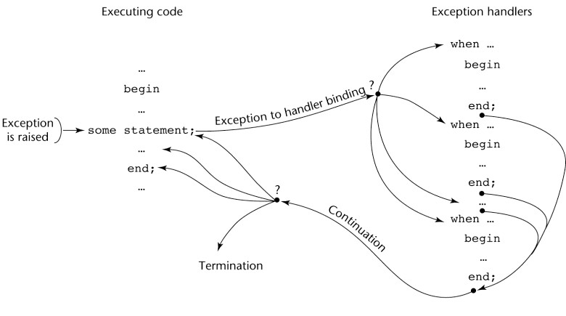

Principles of Programming Language

•Where does execution continue, if at all, after an exception handler completes its execution? (continuation vs. resumption)

•Is some form of finalization provided?   
Exception Handling Control Flow

Exception Handling in Ada

•The frame of an exception handler in Ada is either a subprogram body, a package body, a task, or a block

•Because exception handlers are usually local to the code in which the exception can be raised, they do not have parameters

Ada Exception Handlers

•Handler form:

when exception_choice{|exception_choice} => statement_sequence

[when others =>

statement_sequence]

exception_choice form:

exception_name | others

•Handlers are placed at the end of the block or unit in which they occur Binding Exceptions to Handlers

•If the block or unit in which an exception is raised does not have a handler

Principles of Programming Language

for that exception, the exception is propagated elsewhere to be handled

-Procedures - propagate it to the caller

-Blocks - propagate it to the scope in which it appears

-Package body - propagate it to the declaration part of the unit that   
declared the package (if it is a library unit, the program is terminated)

-Task - no propagation; if it has a handler, execute it; in either case, mark it "completed"

Continuation

•The block or unit that raises an exception but does not handle it is always   
terminated (also any block or unit to which it is propagated that does not   
handle it)

Other Design Choices

•User-defined Exceptions form:

exception_name_list : exception;

•Raising Exceptions form:   
 raise [exception_name]

-(the exception name is not required if it is in a handler--in this case, it propagates the same exception)

•Exception conditions can be disabled with:   
 pragma SUPPRESS(exception_list)

Predefined Exceptions

•CONSTRAINT_ERROR - index constraints, range constraints, etc.

•NUMERIC_ERROR - numeric operation cannot return a correct value (overflow, division by zero, etc.)

•PROGRAM_ERROR - call to a subprogram whose body has not been elaborated

•STORAGE_ERROR - system runs out of heap

•TASKING_ERROR - an error associated with tasks Evaluation

•The Ada design for exception handling embodies the state-of-the-art in

Principles of Programming Language

language design in 1980

•A significant advance over PL/I

•Ada was the only widely used language with exception handling until it was added to C++

Exception Handling in C++

•Added to C++ in 1990

•Design is based on that of CLU, Ada, and ML C++ Exception Handlers

•Exception Handlers Form:   
 try {

-- code that is expected to raise an exception   
}

catch (formal parameter) {

-- handler code

}

catch (formal parameter) {

-- handler code

}

The catch Function

•catch is the name of all handlers--it is an overloaded name, so the formal parameter of each must be unique

•The formal parameter need not have a variable

-It can be simply a type name to distinguish the handler it is in from   
others

•The formal parameter can be used to transfer information to the handler

•The formal parameter can be an ellipsis, in which case it handles all exceptions not yet handled

Throwing Exceptions

•Exceptions are all raised explicitly by the statement:   
 throw [expression];

•The brackets are metasymbols

•A throw without an operand can only appear in a handler; when it appears, it simply re-raises the exception, which is then handled elsewhere

Principles of Programming Language

•The type of the expression disambiguates the intended handler Unhandled Exceptions

•An unhandled exception is propagated to the caller of the function in which it   
is raised

•This propagation continues to the main function Continuation

•After a handler completes its execution, control flows to the first statement   
after the last handler in the sequence of handlers of which it is an element

•Other design choices

-All exceptions are user-defined

-Exceptions are neither specified nor declared

-Functions can list the exceptions they may raise

-Without a specification, a function can raise any exception (the throw   
clause)

Evaluation

•It is odd that exceptions are not named and that hardware- and system software-detectable exceptions cannot be handled

•Binding exceptions to handlers through the type of the parameter certainly does not promote readability

Exception Handling in Java

•Based on that of C++, but more in line with OOP philosophy

•All exceptions are objects of classes that are descendants of the Throwable   
class

Classes of Exceptions

•The Java library includes two subclasses of Throwable :

-Error

•Thrown by the Java interpreter for events such as heap overflow

•Never handled by user programs

-Exception

Principles of Programming Language

•User-defined exceptions are usually subclasses of this

•Has two predefined subclasses, IOException and

RuntimeException (e.g., ArrayIndexOutOfBoundsException and NullPointerException

Java Exception Handlers

•Like those of C++, except every catch requires a named parameter and all parameters must be descendants of Throwable

•Syntax of try clause is exactly that of C++

•Exceptions are thrown with throw, as in C++, but often the throw includes the new operator to create the object, as in: throw new MyException();

Binding Exceptions to Handlers

•Binding an exception to a handler is simpler in Java than it is in C++

-An exception is bound to the first handler with a parameter is the same class as the thrown object or an ancestor of it

•An exception can be handled and rethrown by including a throw in the handler (a handler could also throw a different exception)

Continuation

•If no handler is found in the method, the exception is propagated to the method‘s caller

•If no handler is found (all the way to main), the program is terminated

•To ensure that all exceptions are caught, a handler can be included in any try construct that catches all exceptions

-Simply use an Exception class parameter

-Of course, it must be the last in the try construct Checked and Unchecked Exceptions

•The Java throws clause is quite different from the throw clause of C++

•Exceptions of class Error and RunTimeException and all of their descendants   
are called unchecked exceptions; all other exceptions are called checked   
exceptions

•Checked exceptions that may be thrown by a method must be either:

Principles of Programming Language

-Listed in the throws clause, or

-Handled in the method   
Other Design Choices

•A method cannot declare more exceptions in its throws clause than the method it overrides

•A method that calls a method that lists a particular checked exception in its throws clause has three alternatives for dealing with that exception:

-Catch and handle the exception

-Catch the exception and throw an exception that is listed in its own throws   
clause

-Declare it in its throws clause and do not handle it The finally Clause

•Can appear at the end of a try construct

•Form:

finally {

}

•Purpose: To specify code that is to be executed, regardless of what happens in the try construct

Example

•A try construct with a finally clause can be used outside exception handling

try {

for (index = 0; index < 100; index++) {   
 …

if (…) {

return;

} //** end of if

} //** end of try clause

finally {   
 …

} //** end of try construct

Assertions

Principles of Programming Language

•Statements in the program declaring a boolean expression regarding the current state of the computation

•When evaluated to true nothing happens

•When evaluated to false an AssertionError exception is thrown

•Can be disabled during runtime without program modification or recompilation

•Two forms

-assert condition;

-assert condition: expression;

Evaluation

•The types of exceptions makes more sense than in the case of C++

•The throws clause is better than that of C++ (The throw clause in C++ says little to the programmer)

•The finally clause is often useful

•The Java interpreter throws a variety of exceptions that can be handled by user programs

Logic Programming Languages

Topics

•Introduction

•An Overview of Logic Programming

•The Origins of Prolog

•The Basic Elements of Prolog

•Deficiencies of Prolog

•Applications of Logic Programming Introduction

•Logic programming languages, sometimes called declarative programming languages

•Express programs in a form of symbolic logic

•Use a logical inferencing process to produce results

•Declarative rather that procedural:

-Only specification of results are stated (not detailed procedures for producing   
them)

Proposition

•A logical statement that may or may not be true

-Consists of objects and relationships of objects to each other Symbolic Logic

•Logic which can be used for the basic needs of formal logic:

-Express propositions

-Express relationships between propositions

-Describe how new propositions can be inferred from other propositions

Principles of Programming Language

•Particular form of symbolic logic used for logic programming called predicate   
calculus

Object Representation

•Objects in propositions are represented by simple terms: either constants or variables

•Constant: a symbol that represents an object

•Variable: a symbol that can represent different objects at different times

-Different from variables in imperative languages

Compound Terms

•Atomic propositions consist of compound terms

•Compound term: one element of a mathematical relation, written like a mathematical function

-Mathematical function is a mapping

-Can be written as a table

Parts of a Compound Term

•Compound term composed of two parts

-Functor: function symbol that names the relationship

-Ordered list of parameters (tuple)

•Examples:

student(jon)

like(seth, OSX)

like(nick, windows) like(jim, linux)

Forms of a Proposition

•Propositions can be stated in two forms:

-Fact: proposition is assumed to be true

-Query: truth of proposition is to be determined

•Compound proposition:

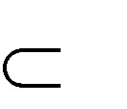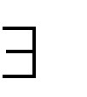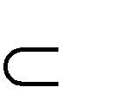

Principles of Programming Language

-Have two or more atomic propositions

-Propositions are connected by operators

Logical Operators

Name Symbol Example Meaning

negation a not a

conjunction a b a and b

disjunction a b a or b

equivalence a b a is equivalent to b

implication a b a implies b

a b b implies a

Quantifiers

Name Example Meaning

universal X.P For all X, P is true

existential X.P There exists a value of X such that P is true

Clausal Form

•Too many ways to state the same thing

•Use a standard form for propositions

•Clausal form:

-B1 B2 … Bn A1 A2 … Am

–means if all the As are true, then at least one B is true

Principles of Programming Language

•Antecedent: right side

•Consequent: left side

Predicate Calculus and Proving Theorems

•A use of propositions is to discover new theorems that can be inferred from known axioms and theorems

•Resolution: an inference principle that allows inferred propositions to be computed from given propositions

Resolution

•Unification: finding values for variables in propositions that allows matching process to succeed

•Instantiation: assigning temporary values to variables to allow unification to   
succeed

•After instantiating a variable with a value, if matching fails, may need to backtrack and instantiate with a different value

Theorem Proving

•Basis for logic programming

•When propositions used for resolution, only restricted form can be used

•Horn clause - can have only two forms

-Headed: single atomic proposition on left side

-Headless: empty left side (used to state facts)

•Most propositions can be stated as Horn clauses Overview of Logic Programming

•Declarative semantics

-There is a simple way to determine the meaning of each statement

-Simpler than the semantics of imperative languages

•Programming is nonprocedural

-Programs do not state now a result is to be computed, but rather the form of the result

Principles of Programming Language

The Origins of Prolog

•University of Aix-Marseille

-Natural language processing

•University of Edinburgh

-Automated theorem proving

Terms

•Edinburgh Syntax

•Term: a constant, variable, or structure

•Constant: an atom or an integer

•Atom: symbolic value of Prolog

•Atom consists of either:

-a string of letters, digits, and underscores beginning with a lowercase letter

-a string of printable ASCII characters delimited by apostrophes Terms: Variables and Structures

•Variable: any string of letters, digits, and underscores beginning with an uppercase letter

•Instantiation: binding of a variable to a value

-Lasts only as long as it takes to satisfy one complete goal

•Structure: represents atomic proposition

functor(parameter list)

Fact Statements

•Used for the hypotheses

•Headless Horn clauses   
 female(shelley).

male(bill).

father(bill, jake).

Rule Statements

•Used for the hypotheses

Principles of Programming Language

•Headed Horn clause

•Right side: antecedent (if part)

-May be single term or conjunction

•Left side: consequent (then part)

-Must be single term

•Conjunction: multiple terms separated by logical AND operations (implied)

Example Rules

ancestor(mary,shelley):- mother(mary,shelley).

•Can use variables (universal objects) to generalize meaning:   
 parent(X,Y):- mother(X,Y).

parent(X,Y):- father(X,Y).

grandparent(X,Z):- parent(X,Y), parent(Y,Z). sibling(X,Y):- mother(M,X), mother(M,Y),   
 father(F,X), father(F,Y).

Goal Statements

•For theorem proving, theorem is in form of proposition that we want system to prove or disprove - goal statement

•Same format as headless Horn   
 man(fred)

•Conjunctive propositions and propositions with variables also legal goals   
 father(X,mike)

Inferencing Process of Prolog

•Queries are called goals

•If a goal is a compound proposition, each of the facts is a subgoal

•To prove a goal is true, must find a chain of inference rules and/or facts. For goal Q:

B :- A

C :- B   
…

Q :- P

Principles of Programming Language

•Process of proving a subgoal called matching, satisfying, or resolution Approaches

•Bottom-up resolution, forward chaining

-Begin with facts and rules of database and attempt to find sequence that leads to goal

-Works well with a large set of possibly correct answers

•Top-down resolution, backward chaining

-Begin with goal and attempt to find sequence that leads to set of facts in database

-Works well with a small set of possibly correct answers

•Prolog implementations use backward chaining Subgoal Strategies

•When goal has more than one subgoal, can use either

-Depth-first search: find a complete proof for the first subgoal before working on others

-Breadth-first search: work on all subgoals in parallel

•Prolog uses depth-first search

-Can be done with fewer computer resources Backtracking

•With a goal with multiple subgoals, if fail to show truth of one of subgoals,   
reconsider previous subgoal to find an alternative solution: backtracking

•Begin search where previous search left off

•Can take lots of time and space because may find all possible proofs to every   
subgoal

Simple Arithmetic

•Prolog supports integer variables and integer arithmetic

•is operator: takes an arithmetic expression as right operand and variable as left operand

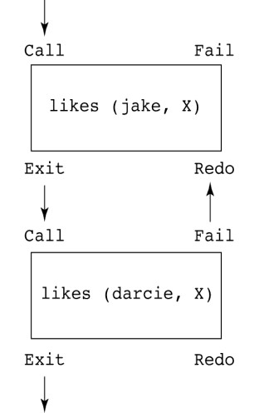

Principles of Programming Language

A is B / 17 + C

•Not the same as an assignment statement!

Example

speed(ford,100).   
speed(chevy,105).   
speed(dodge,95).   
speed(volvo,80).   
time(ford,20).   
time(chevy,21).   
time(dodge,24).   
time(volvo,24).

distance(X,Y) :- speed(X,Speed),

time(X,Time),

Y is Speed * Time.

Trace

•Built-in structure that displays instantiations at each step

•Tracing model of execution - four events:

-Call (beginning of attempt to satisfy goal)

-Exit (when a goal has been satisfied)

-Redo (when backtrack occurs)

-Fail (when goal fails)

Example

likes(jake,chocolate).   
likes(jake,apricots).   
likes(darcie,licorice).   
likes(darcie,apricots).

trace.

likes(jake,X),   
likes(darcie,X).

Principles of Programming Language

List Structures

•Other basic data structure (besides atomic propositions we have already seen): list

•List is a sequence of any number of elements

•Elements can be atoms, atomic propositions, or other terms (including other   
lists)

[apple, prune, grape, kumquat]

[] (empty list)

[X | Y] (head X and tail Y)

Append Example

append([], List, List).

append([Head | List_1], List_2, [Head | List_3]) :-  
append (List_1, List_2, List_3).

Reverse Example

reverse([], []).

reverse([Head | Tail], List) :-  
reverse (Tail, Result),

append (Result, [Head], List).

Deficiencies of Prolog

•Resolution order control

•The closed-world assumption

•The negation problem

•Intrinsic limitations

Applications of Logic Programming

•Relational database management systems

•Expert systems

•Natural language processing

Principles of Programming Language

Summary

•Symbolic logic provides basis for logic programming

•Logic programs should be nonprocedural

•Prolog statements are facts, rules, or goals

•Resolution is the primary activity of a Prolog interpreter

•Although there are a number of drawbacks with the current state of logic

programming it has been used in a number of areas

Principles of Programming Language

UNIT – V

Functional Programming Language

Functional Programming Language Introduction

•The design of the imperative languages is based directly on the von Neumann architecture

-Efficiency is the primary concern, rather than the suitability of the language for software development

•The design of the functional languages is based on mathematical functions

-A solid theoretical basis that is also closer to the user, but relatively   
unconcerned with the architecture of the machines on which programs   
will run

Mathematical Functions

•A mathematical function is a mapping of members of one set, called the domain set, to another set, called the range set

•A lambda expression specifies the parameter(s) and the mapping of a function in the following form

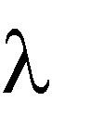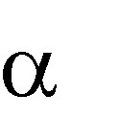

Principles of Programming Language

(x) x * x * x

for the function cube (x) = x * x * x

Lambda Expressions

•Lambda expressions describe nameless functions

•Lambda expressions are applied to parameter(s) by placing the parameter(s) after the expression

e.g., ( (x) x * x * x)(2)

which evaluates to 8

Functional Forms

•A higher-order function, or functional form, is one that either takes functions as parameters or yields a function as its result, or both

Function Composition

•A functional form that takes two functions as parameters and yields a function whose value is the first actual parameter function applied to the application of the second

Form: h f ° g

which means h (x) f ( g ( x))

For f (x) x + 2 and g (x) 3 * x, h f ° g yields (3 * x)+ 2

Apply-to-all

•A functional form that takes a single function as a parameter and yields a list   
of values obtained by applying the given function to each element of a list of   
parameters

Form:

For h (x) x * x

( h, (2, 3, 4)) yields (4, 9, 16)

Fundamentals of Functional Programming Languages

•The objective of the design of a FPL is to mimic mathematical functions to the greatest extent possible

•The basic process of computation is fundamentally different in a FPL than in an imperative language

-In an imperative language, operations are done and the results are stored in variables for later use

-Management of variables is a constant concern and source of

Principles of Programming Language

complexity for imperative programming

•In an FPL, variables are not necessary, as is the case in mathematics Referential Transparency

•In an FPL, the evaluation of a function always produces the same result given the same parameters

LISP Data Types and Structures

•Data object types: originally only atoms and lists

•List form: parenthesized collections of sublists and/or atoms   
 e.g., (A B (C D) E)

•Originally, LISP was a typeless language

•LISP lists are stored internally as single-linked lists LISP Interpretation

•Lambda notation is used to specify functions and function definitions. Function applications and data have the same form.

e.g., If the list (A B C) is interpreted as data it is   
a simple list of three atoms, A, B, and C   
If it is interpreted as a function application,   
it means that the function named A is   
applied to the two parameters, B and C

•The first LISP interpreter appeared only as a demonstration of the universality of the computational capabilities of the notation

ML

•A static-scoped functional language with syntax that is closer to Pascal than   
to LISP

•Uses type declarations, but also does type inferencing to determine the types of undeclared variables

•It is strongly typed (whereas Scheme is essentially typeless) and has no type coercions

•Includes exception handling and a module facility for implementing abstract data types

Principles of Programming Language

•Includes lists and list operations ML Specifics

•Function declaration form:

fun name (parameters) = body;   
e.g., fun cube (x : int) = x * x * x;

- The type could be attached to return value, as in   
 fun cube (x) : int = x * x * x;

- With no type specified, it would default to   
 int (the default for numeric values)

- User-defined overloaded functions are not allowed, so if we wanted a cube function for real parameters, it would need to have a different name

- There are no type coercions in ML

•ML selection

if expression then then_expression else else_expression

where the first expression must evaluate to a Boolean value

•Pattern matching is used to allow a function to operate on different parameter forms

fun fact(0) = 1

| fact(n : int) : int =

n * fact(n - 1)

•Lists

Literal lists are specified in brackets   
[3, 5, 7]

[] is the empty list

CONS is the binary infix operator, ::

4 :: [3, 5, 7], which evaluates to [4, 3, 5, 7] CAR is the unary operator hd

CDR is the unary operator tl fun length([]) = 0

| length(h :: t) = 1 + length(t);

fun append([], lis2) = lis2

| append(h :: t, lis2) = h :: append(t, lis2);

•The val statement binds a name to a value (similar to DEFINE in Scheme) val distance = time * speed;

- As is the case with DEFINE, val is nothing like an assignment statement in

an imperative language.

Principles of Programming Language

Haskell

•Similar to ML (syntax, static scoped, strongly typed, type inferencing, pattern matching)

•Different from ML (and most other functional languages) in that it is purely   
functional (e.g., no variables, no assignment statements, and no side effects of   
any kind)

Syntax differences from ML fact 0 = 1

fact n = n * fact (n - 1)

fib 0 = 1

fib 1 = 1

fib (n + 2) = fib (n + 1) + fib n

Function Definitions with Different Parameter Ranges

fact n

| n == 0 = 1

| n > 0 = n * fact(n - 1)

sub n

| n < 10 = 0

| n > 100 = 2

| otherwise = 1

square x = x * x

- Works for any numeric type of x

Lists

•List notation: Put elements in brackets

e.g., directions = ["north",

•Length: #

e.g., #directions is 4

•Arithmetic series with the .. operator   
 e.g., [2, 4..10] is [2, 4, 6, 8, 10]

•Catenation is with ++

"south", "east", "west"]

Principles of Programming Language

e.g., [1, 3] ++ [5, 7] results in [1, 3, 5, 7]

•CONS, CAR, CDR via the colon operator (as in Prolog)   
 e.g., 1:[3, 5, 7] results in [1, 3, 5, 7]

Factorial Revisited

product [] = 1

product (a:x) = a * product x

fact n = product [1..n]

List Comprehension

•Set notation

•List of the squares of the first 20 positive integers: [n * n | n ← [1..20]]

•All of the factors of its given parameter:

factors n = [i | i ← [1..n div 2],

n mod i == 0]

Quicksort

sort [] = []   
sort (a:x) =

sort [b | b ← x; b <= a] ++   
[a] ++

sort [b | b ← x; b > a]

Lazy Evaluation

•A language is strict if it requires all actual parameters to be fully evaluated

•A language is nonstrict if it does not have the strict requirement

•Nonstrict languages are more efficient and allow some interesting capabilities

- infinite lists

•Lazy evaluation - Only compute those values that are necessary

•Positive numbers

positives = [0..]

•Determining if 16 is a square number   
 member [] b = False

member(a:x) b=(a == b)||member x b squares = [n * n | n ← [0..]]

member squares 16

Principles of Programming Language

Member Revisited

•The member function could be written as:   
 member [] b = False

member(a:x) b=(a == b)||member x b

•However, this would only work if the parameter to squares was a perfect square; if not, it will keep generating them forever. The following version will always work:

member2 (m:x) n

| m < n = member2 x n | m == n = True

| otherwise = False

Applications of Functional Languages

•APL is used for throw-away programs

•LISP is used for artificial intelligence

-Knowledge representation

-Machine learning

-Natural language processing

-Modeling of speech and vision

•Scheme is used to teach introductory programming at some universities Comparing Functional and Imperative Languages

•Imperative Languages:

-Efficient execution

-Complex semantics

-Complex syntax

-Concurrency is programmer designed

•Functional Languages:

-Simple semantics

-Simple syntax

Principles of Programming Language

-Inefficient execution

-Programs can automatically be made concurrent

Summary

•Ada provides extensive exception-handling facilities with a comprehensive set of built-in exceptions.

•C++ includes no predefined exceptions Exceptions are bound to handlers by connecting the type of expression in the throw statement to that of the formal parameter of the catch function

•Java exceptions are similar to C++ exceptions except that a Java exception must be a descendant of the Throwable class. Additionally Java includes a finally clause

•Functional programming languages use function application, conditional expressions, recursion, and functional forms to control program execution instead of imperative features such as variables and assignments

•LISP began as a purely functional language and later included imperative   
features

•Scheme is a relatively simple dialect of LISP that uses static scoping exclusively

•COMMON LISP is a large LISP-based language

•ML is a static-scoped and strongly typed functional language which includes type inference, exception handling, and a variety of data structures and   
abstract data types

•Haskell is a lazy functional language supporting infinite lists and set comprehension.

•Purely functional languages have advantages over imperative alternatives,

but their lower efficiency on existing machine architectures has prevented them from enjoying widespread use.

**Scripting language**

A scripting language is a programming language that employs a high-level construct to interpret and execute one command at a time. In general, scripting languages are easier to learn and faster to code in than more structured and [compiled](http://whatis.techtarget.com/definition/compiler) languages such as [C](http://searchwindowsserver.techtarget.com/definition/C) and [C++](http://searchsqlserver.techtarget.com/definition/C).

Compiled languages are converted permanently into [executable](http://searchsecurity.techtarget.com/definition/executable) files before they are run. In contrast, scripting languages are typically converted into [machine code](http://whatis.techtarget.com/definition/machine-code-machine-language) on the fly during [runtime](http://searchsoftwarequality.techtarget.com/definition/runtime) by a program called an [interpreter](http://whatis.techtarget.com/definition/interpreted-script). Although this approach can cause performance problems because the [instructions](http://searchcio-midmarket.techtarget.com/definition/instruction) are not handled solely by the [processor](http://whatis.techtarget.com/definition/processor), it does make it easier for [scripts](http://searchenterpriselinux.techtarget.com/definition/script) to work with programs written in other languages.

Over time, as j[ust-in-time compilation](http://whatis.techtarget.com/definition/just-in-time-compiler-JIT) has improved performance and intepreted programming languages like Perl, Python and Ruby have evolved, the lines have begun to blur about what should, and what should not, be classified as a scripting language. Today, it is generally agreed that the classification should not be determined by the language itself, but rather by how the language is being used.

When a scripting language is used to connect disparate system components, it may also be referred to as a [glue language](http://whatis.techtarget.com/definition/glue-code).  In addition to being interpreted, such scripting languages are also typeless, allowing a [variable](http://whatis.techtarget.com/definition/variable) to hold any type of data without having to explicitly declare its type. Usually, glue languages also provide native support for specific [aggregate](http://whatis.techtarget.com/definition/aggregate) data types such as [arrays](http://searchstorage.techtarget.com/definition/array) and automate [garbage collection](http://searchstorage.techtarget.com/definition/garbage-collection) to reclaim abandoned storage and prevent [memory leaks](http://searchwindowsserver.techtarget.com/definition/memory-leak).

Scripting languages like JavaScript are often used to facilitate enhanced features of websites. These features are processed on the [server](http://whatis.techtarget.com/definition/server), but the script on a specific page runs on the user's [browser](http://searchwindevelopment.techtarget.com/definition/browser). Many Web sites require that the user's browser be set to run scripts to take advantage of all the features of the site. In some cases, a Web site may be practically useless unless the user's computer is set to run programs locally in a scripting language.

**Scripting languages defined elsewhere on WhatIs.com include:**

[AppleScript](http://whatis.techtarget.com/definition/AppleScript) - AppleScript programs ([applets](http://searchsoa.techtarget.com/definition/applet)) perform like [bots](http://searchsoa.techtarget.com/definition/bot): once they are written, they can autonomously process and manage multimedia data, including digital video, text and Web-based material.

[bash](http://searchenterpriselinux.techtarget.com/definition/bash) - the free version of the Bourne shell distributed with Linux and GNU operating systems.

[Bourne shell](http://searchenterpriselinux.techtarget.com/definition/Bourne-shell) - the original UNIX shell. Also known by its program name, sh.

[C shell](http://whatis.techtarget.com/definition/C-shell) - invented for programmers who prefer a syntax similar to that of the C programming language.

[JavaScript](http://searchsoa.techtarget.com/definition/JavaScript) - script language developed by Netscape. It is somewhat similar in capability to Microsoft's [Visual Basic](http://searchwindevelopment.techtarget.com/definition/Visual-Basic), Sun's [Tcl](http://searchenterpriselinux.techtarget.com/definition/Tcl-Tk), the UNIX-derived [Perl](http://searchenterpriselinux.techtarget.com/definition/Perl), and IBM's [REXX](http://searchdatacenter.techtarget.com/definition/Rexx).

[Korn shell](http://whatis.techtarget.com/definition/Korn-shell) - incorporatins all the features of C shell (csh) and Tab C-shell  (tcsh) with the script language features similar to that of the Bourne shell

[LotusScript](http://searchdomino.techtarget.com/definition/LotusScript) - can be coded within the Lotus Domino Designer development environment.

[Perl](http://searchenterpriselinux.techtarget.com/definition/Perl) - a script programming language that is similar in syntax to the C language; can optionally be compiled just before execution into either C code or cross-platform [bytecode](http://searchcio-midmarket.techtarget.com/definition/bytecode).

[PHP](http://searchenterpriselinux.techtarget.com/definition/PHP) - a script language and interpreter that is freely available and used primarily on Linux Web servers.

[PowerShell](http://searchwindowsserver.techtarget.com/definition/PowerShell) - designed to automate system tasks, such as batch processing, and create systems management tools for commonly implemented processes; includes more than 130 standard command line tools for functions that formerly required users to create scripts in [VB](http://searchwindevelopment.techtarget.com/definition/Visual-Basic), [VBScript](http://searchenterprisedesktop.techtarget.com/definition/VBScript) or [C#](http://searchwindevelopment.techtarget.com/definition/C).

[Python](http://searchenterpriselinux.techtarget.com/definition/Python) - often used to provide scripting capability to existing applications; is simple enough for user-level scripting with a minimum of training.

[Ruby](http://whatis.techtarget.com/definition/Ruby) - according to proponents, Ruby's simple syntax (partially inspired by [Ada](http://whatis.techtarget.com/definition/Ada) and [Eiffel](http://whatis.techtarget.com/definition/Eiffel)), makes it readable by anyone who is familiar with any modern programming language.

**Pragmatics:**

Scripting is defined as a process of writing small sized programs.The main usage of scripting is to automate the manual work using computer system and to represent the output in readable format.

Scripting is based on following Criteria

1. Usage of script
2. Rapid development b
3. Efficiency requirement
4. High level functionality

KEY CONCEPTS

Characteristics of scripting language

1. Simple scoping rules
2. Direct access to other programs
3. Flexible dynamic typing
4. High level pattern matching and string manipulation process
5. Inbuilt high level datatypes
6. Optimum utilization of expressions
7. Efficient batch and command line computing

**VALUES AND TYPES**

**Values**: Python adheres to type completion principle as it considers procedures as first class values with both primitive and composite values.

Python supports following types of expressions.

Procedure calls

Iterative expressions

Constructions.

1. Tuple construction
2. List construction
3. List Comprehension
4. Dictionary Construction

**Data Types:**

1. Primitive types

Python supports only limited set of primitive types that include the following

1. Integer
2. Real
3. Complex
4. Composite Types

Pyhton supports rich set of composite types that include the following

1. Tuple
2. String
3. Lists
4. Dictionary

#### Python is simple

In general, scripting languages are much simpler than system languages like C++ and Java (Laird & Soraiz, 1998b). Python has a simple, regular syntax. Statements are terminated by end of line, and block structure is indicated by indentation. Python programs look like executable pseudo-code. This eliminates a host of troublesome errors for beginning programmers, especially placement of semi-colons, bracketing and indentation. For example, a common error in C++ and Java is the failure to enclose a block in braces as:

if (x < 0)

cout << "x was negative";

x = -x;

In Python the corresponding code executes as expected, since the indentation itself determines the block:

if x < 0:

print "x was negative"

x = -x

Python supports the use of functions and classes but does not force it. Simple programs really are simple. For example, consider the ubiquitous ``Hello World'' program in Python:

print "Hello World!"

C++ requires this program to be wrapped in a function and preceded by a preprocessor directive:

#include <iostream.h>

int main()

{

cout << "Hello World!";

}

In Java, the situation is even worse, as all code must be inside of a class:

public class helloWorld

{

public static void main(String [] args)

{

System.out.println("Hello World!");

}

}

Semantically, Python is also simple. Python is dynamically typed, so there is no need for variable declarations. This reduces the amount of code that students have to write and also eliminates common errors stemming from misunderstanding the subtle distinctions of declaration, definition and use. For example, students in C++ and Java often ``accidently'' redeclare variables where they really only want to use them (typing int count = 0; when they mean count = 0). Such mistakes can be hard to track down.

Python has a minimal but complete set of simple control structures: one selection construct (if-elif-else), one definite loop (for) and one indefinite loop (while). Python also has a modern exception handling mechanism similar to that found in C++ and Java. Unlike Java, however, you do not have to understand the exception mechanism to write simple programs. From a pedagogical perspective, Python's for loop is illustrative. It allows a control variable to take on successive values in a sequence. It can be used to iterate through any sequence such as a list (array) or string. For example, the items in a list can be printed as follows:

for item in List:

print item

The range operation produces a sequence of numbers in a given range. For example, range(5) produces the list [0,1,2,3,4]. This can be used to provide numerically-controlled loops. The previous code could have been written (less clearly) as:

for i in range(len(List)):

print List[i]

The for loop is simple and safe, allowing it to be introduced very early with no fear of infinite loops.

Python has a simple uniform data model. Variables are always references to heap allocated values (objects). The model is consistent, avoiding the confusion over heap versus automatic variables in C++ or primitive versus object types in Java. Both of these languages require the teaching of multiple allocation models to implement even relatively simple programs.

Similarly, Python has only a single parameter passing mechanism (by value). Parameter passing is simply assignment of actual to formal parameters at call time. Once students understand the simple assignment model, they get parameter passing for free.

#### Python is safe

Python provides full dynamic run-time type checking and bounds checking on array subscripts. Python employs garbage collection so there is no problem with dangling pointers or memory leaks. It is impossible for user code in Python to produce a segmentation violation. In this respect Python is similar to Java, and both are much safer than C++.